# **Chapter-1**

# **Introduction**

Now online business became the easy and faster growing business. As the use of technology is rapidly increasing day after day. In the present time, technology is being use for every possible thing. Online business is also the must growing network. People are now modern and technology dependent they want everything easy and faster. Mobile phones, laptops and other technologies are being use rapidly. Nowadays everything is possible by the use of these technologies. By the use of these now people can order everything at their place, which end the tension of going to the market to buy anything. This type of business now provides faster services.

## 1.1 Background of the system.

Online liquor store is the web-based business, which is going to sell wines, beers, hard drinks, or other different types of the drinks. Nowadays ton of people, male and female alike, consume liquor on a daily basis. This proves that there is a big market for liquor business and as an aspiring entrepreneur looking for a business to start. Online liquor market will be the big project to complete as their possibly will be the large demand of the product.

For this project, there will be the web application that will provide the details about the liquor available and their price. This web site will be the user friendly as people can easily order their products. By the use of this site people need not to visit stores to buy liquors, they can order to their place. Now anyone can track everything about liquors, price of liquor just clicking it of web app on online. I have used PHP for programming and My SQL for manage database of liquors.

## 1.2 Justification of project.

Online liquor store is the web-based application, which will provide the facility of ordering the liquors online. With this application customer can view product and their prices. But for the ordering the product customer have to register and login into the system. This application provides the best user interface that will make users to visit this site again.

## 1.3 Features of the application

* User can Register and Login to the system.
* User can view and order products
* User can edit their details
* Admin can add and remove products.
* Admin can confirm and delete users.
* Admin can view and confirm orders.
* User can reset their password.

## 1.4 Aims and Objectives

### 1.4.1 Aims

* To develop a web based application so that everything related to our online liquor store can be made available online
* To provide better, reliable and faster service.
* To expand the business and to provide the best products.
* To maintain custom satisfaction and to promote new products.
* To save money, time and effort which waste on visiting the shops.
* Promote the use of the technology.

### 1.4.2 Objectives

* To keep all the record of the products and customer details.
* To provide better service to the customers.
* To keep the customer data systematically.
* To create the secured database.
* Members login to view their details.
* Registering new members through the system.
* To provide the better quality product to the customer.

## 

## 1.5 Scope

Online liquor store is the web-based application developed for increasing the liquor business online. This system will help to view all the drinks available in the store. This will allow registering and login in to the system for ordering the products. This systems UI system is very user friendly and very easy to use.

# Chapter 2

# Analysis

## 2.1 Introduction to analysis

Analysis is the initial stage in building a system is to understand what that system should be. Better analysis leads us to the better understanding is the system and help to know the limitations of the system. Analysis works as the bridge between the information we have and the way the system should actually work. During analysis phase, requirement analysis is the most important step to be followed carefully.

In requirement analysis phase, requirements are gathered. The process of gathering the requirement is perform by interviews, focus group, questionnaires etc. Requirement analysis provides the user requirements, system requirements, how the system functions so on. A software requirements specificationis also provided, which includes details of the functional requirements of the system, such as the interactions between the users and the software and the non-functional requirements, e.g. the quality standards. Analysis are of different types such as PEST analysis, SWOT analysis, CATWOE analysis, etc.

For my project I have used PEST analysis. PEST stands for Political, Economic, Social and Technological. This analysis help to understand how external forces can affect the business. It is the tactical tool used for understanding market growth or market downfall, knowledge management and strategic planning.

PEST analysis mainly work for following factors:

1. Political

Political factor relates with the government interferes in the economy. Political factors includes tax policy, environmental policy, political instability, safety regulations, etc.

Political factors that can affect my projects are:

* Tax law
* Environmental policy as liquor business can affect the environment of the society so our online liquor shop will supply only in limited hours.
* As government changes policies will may be change.
* safety regulations

1. Economic

Economic factorsassess local, national and global influence on the organization. It includes following factors:

* economic growth of the organization
* maintaining tax rates
* Maintaining exchange rates
* Organizations progress rate.

1. Social

Social factor assess ways in which a society can influence an organisation. It includes following factors:

* cultural aspects and health awareness
* High trends in social factors affect the demand for organization products
* career approaches and prominence on safety

1. Technological

Technological factors assess the impact of new and emerging technology on an organisation. It has the huge impact on the organization as technology of increasing day by day, which is leading to automation. With increasing technology it is difficult to maintain upgrade the as technology increases.

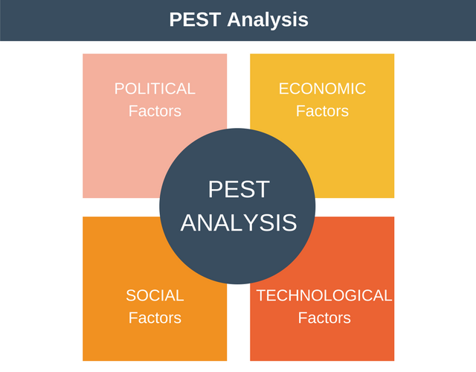

Figure: PEST analysis

## 2.2 Need for analysis

Analysis phase is the most important phase of each project as it help in different aspects such as:

* Gathering and analysis the information for project feasibility.
* Requirements of the project are analyze in this phase.
* Requirement are prioritize in this phase.
* Software Requirement Specification (SRS) is prepared in this phase.
* Use case is develop in this phase, which provide various function that the user and admin would do in the system.
* Initial class diagram is also develop to provide idea of how system would be.

## 2.3 Object oriented analysis

Object oriented analysis technique is used in during the software development life cycle. In this analysis process all the functions and models are created independent on the implementation process. During this process the designs are created around the methods and class. The graphical model is create in this process such as class diagram.

## 2.4 Feasibility study

A feasibility study is an analysis that is done for gathering the project's important factors to determine the likelihood of completing the project successfully. This is done to understand thoroughly all the aspects of the project and potential problems may arise in the future.

It provides the information about the project that is going to develop is economically, socially, legally, technologically and politically feasible or not.

Types of feasibility study:

1. Economic feasibility

Economic feasibility provide the information about the product is going to develop is within the budget or not. It also tells about project that is going to develop is economically beneficial or not.

1. Technical feasibility

It tells about the technological resources that are used for the development of the project are sufficient or not. In addition, tells about the processes and procedures undertaken are beneficial to project success.

1. Schedule feasibility

It provides the knowledge about the time calculated for project is enough or not means that, “Does currently I have the time resources to undertake the project?” This project is aimed to be completed in time successfully.

1. Operational feasibility

This measures how well the user can interact with the system. This also measures how well developer able to solve the problems in mean time. This Online Liquor store website is easy to interact.

1. Legal feasibility

This measure the project is able to meet the legal requirements. By help of this feasible study, we can make sure that the project undertaken will meet all legal requirements before the project is on the table.

## 2.5 Requirement analysis

1. Functional requirements

Functional requirement describes about what the system or website should do also tells about the behavior of the system. It describe what type of system user expect. It describe about the data processing of the system.

Following are the functional requirements of the website:

|  |  |  |  |  |  |
| --- | --- | --- | --- | --- | --- |
| **F.ID** | **Functions** | **Data** | **Rational** | **Dependency** | **Remarks** |
| F01 | Registration | Users will be register with required information. | User information | F01 | Create new account |
| F02 | Login | Username and password. | Security | F01 | Open dashboard |
| F03 | Reset Password | Email/username | Reset password | F02 | Set new password |
| F04 | Post items | Login first | To post new products | F02 | Products will be post for all users. |
| F05 | Make order | - | To select the items needed. | N/A | Users can order they want. |
| F06 | Manage order | Order details | To view the orders details  Lately. | F02 | Admin can manage the orders. |
| F07 | Delete items | Item details | Admin | F02 | Admin can delete the items. |
| F08 | Payment | User can pay after order delivered. | To pay for the item. | N/A | User should pay with hand cash. |
| F09 | Add categories | It is easy to find the items in related category. | Admin can categories the items | F02 | Admin can categories. |
| F010 | Logout | - | To maintain session | F02 | Admin or user can logout |

1. Non-functional requirements

Non-functional requirements illustrate system qualities, for example, security, reliability, maintainability, robustness, usability, etc. They ensure to get best result from the system.

Non-functional requirements are listed below:

|  |  |  |  |  |  |
| --- | --- | --- | --- | --- | --- |
| **N:ID** | **Functions** | **Data** | **Rational** | **Dependency** | **Remarks** |
| N01 | Reusability | - | For future use | N01 | Codes can be reused |
| N02 | Responsive | - | System should be responsive | N02 | Fit in any screen resolution |
| N03 | Maintainability | - | Easy to maintain | N03,N01 | Easy Maintenance |
| N04 | Reliable | - | Maintain Accuracy | N02 | Provide accurate result |
| N05 | Robust | - | Support different device | N05 | Should work in different devices. |
| N06 | Multi-Browser support | - | Tested in different browsers | N02 | Should run in at least two browsers |
| N07 | Performance | - | To maintain systems accuracy | N01,N04 | Test should be done in regular interval |

1. MoSCoW Priotization

MoSCoW Priotization is the method to maintain requirements. This method is used to help key stakeholders understand the important of activities in a certain release.

This letters stand for:

1. **M**ust have

* Project won’t be complete without this
* Cannot provide a workable solution without it

1. **S**hould have

* Important but if not project still work
* If added project will provide worth able solution

1. **C**ould have

* Nice to have
* If left out will not affect the processing

1. **W**on’t Have this time

* This time not possible to add

For functional requirements

|  |  |  |
| --- | --- | --- |
| **F.ID** | **Functions** | **Priority** |
| F01 | Registration | Must have |
| F02 | Login | Must have |
| F03 | Reset Password | Should have |
| F04 | Post items | Must have |
| F05 | Make order | Must have |
| F06 | Manage order | Could have |
| F07 | Delete items | Should have |
| F08 | Payment | Must have |
| F09 | Add categories | Could have |
| F10 | Logout | Should have |
| F11 | Online payment | Won’t have this time |

Table: table of functional requirements priotization

For non-functional requirements

|  |  |  |
| --- | --- | --- |
| **N:ID** | **Functions** | **Priority** |
| N01 | Reusability | Must have |
| N02 | Responsive | Must have |
| N03 | Maintainability | Must have |
| N04 | Reliable | Could have |
| N05 | Robust | Must have |
| N06 | Multi-Browser support | Must have |
| N07 | Performance | Could have |

Table: table for non-functional requirements priotization.

1. Software Requirement Specification(SRS)

A software requirements specification (SRS) is a document that help to list out the detail information about how the software is likely to execute. It is generally listed at the last of requirements gathering phase completed. Some qualities of SRS are Correct, ambiguous, complete, consistent, modifiable, etc.

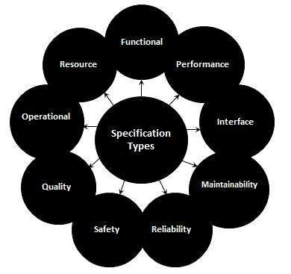

Figure: some type of requirements that SRS can list.

## Use case

Use case diagram is a significant tool in handling the abstractions. It allows representing the broad interactions between parts of a system. It is used to represent the set of functionality that must be supported for each part. Those parts are called actors. They may be users or may be subsystems.

* + Actors are represented by stick figures.

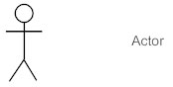

* + Actions are represented by ovals in which a broad description of the process is placed.

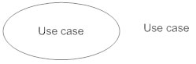

* + A relationship between the actors and use cases are maintained by a line which connects the actor and the action they can perform.

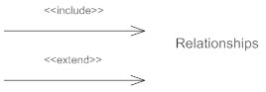

Now, I have designed a Use-case diagram for my project.

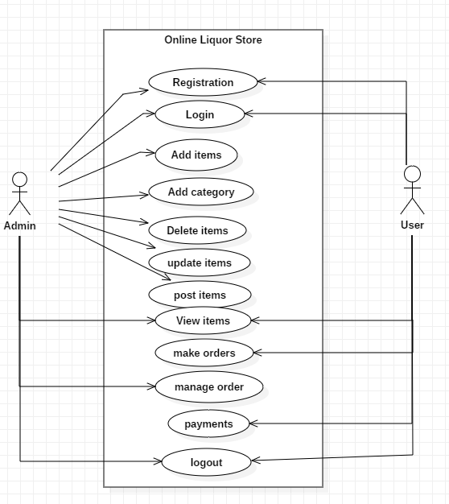

Figure: Use-case diagram.

## Initial class diagram (NLA)

Natural Language Analysis (NLA) is the process of identifying nouns, adjectives and verbs in a part of descriptive text. It is used to obtain a list of candidate classes, their relationships and their attributes.

* + - Nouns relate to potential classes
    - Adjectives relate to potential attributes
    - Verbs relate to potential functionality that must be represented.

**Background of the project**

Online liquor store is the online business, which is going to sell every possible wines, beers, or other types of liquors. Online liquor market will be the big project to complete as their possibly will be the large demand of the product. For this project, there will be the web application that will provide the details about the liquor available and their price. This web site will be the user friendly as people can easily order their products. By the use of this site people need not to visit stores to buy liquors, they can order to their place. Now anyone can track everything about liquors, price of liquor just clicking it of web app on online. I have used PHP for programming and My SQL for manage database of liquors. Features of this website are

* User can Register and Login to the system.
* User can order products from nearby places.
* User can rate products and service of the organisation.
* User also can see the reviews in each products.
* Admin can add new products.
* User can see lists of Upcoming products with prices.
* Database will be designed to keep the details of the products and customers.

Natural language analysis

|  |  |
| --- | --- |
| **Nouns** | **Verbs** |
| User, admin, login, registration, items, category, Job, System, Data, , Name, Email, Plan, Day, Space, Code, Size, Type, Title, Time, Date, Size | Add, Remove, delete, update, manage, registered, order, Done, Allow, Save, Accessing, Complete, Submit |

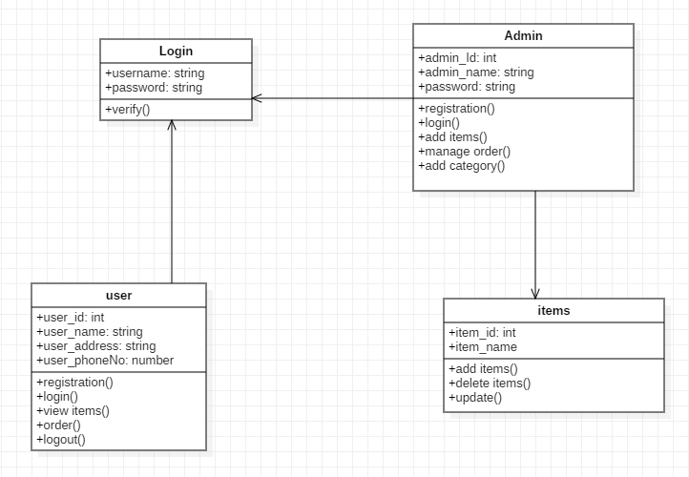

Figure: initial class diagram

## Architecture

**Design pattern**

In software engineering, a **design pattern** is a general repeatable solution to a commonly occurring problem in software design. A design pattern is not a finished design that can be transformed directly into code. It is a description or template for how to solve a problem that can be used in many different situations.

For this project I have used MVC (Model View Controller) design pattern as it that separates domain/application/business (whatever you prefer) logic from the rest of the user interface. It does this by separating the application into three parts: the model, the view, and the controller.

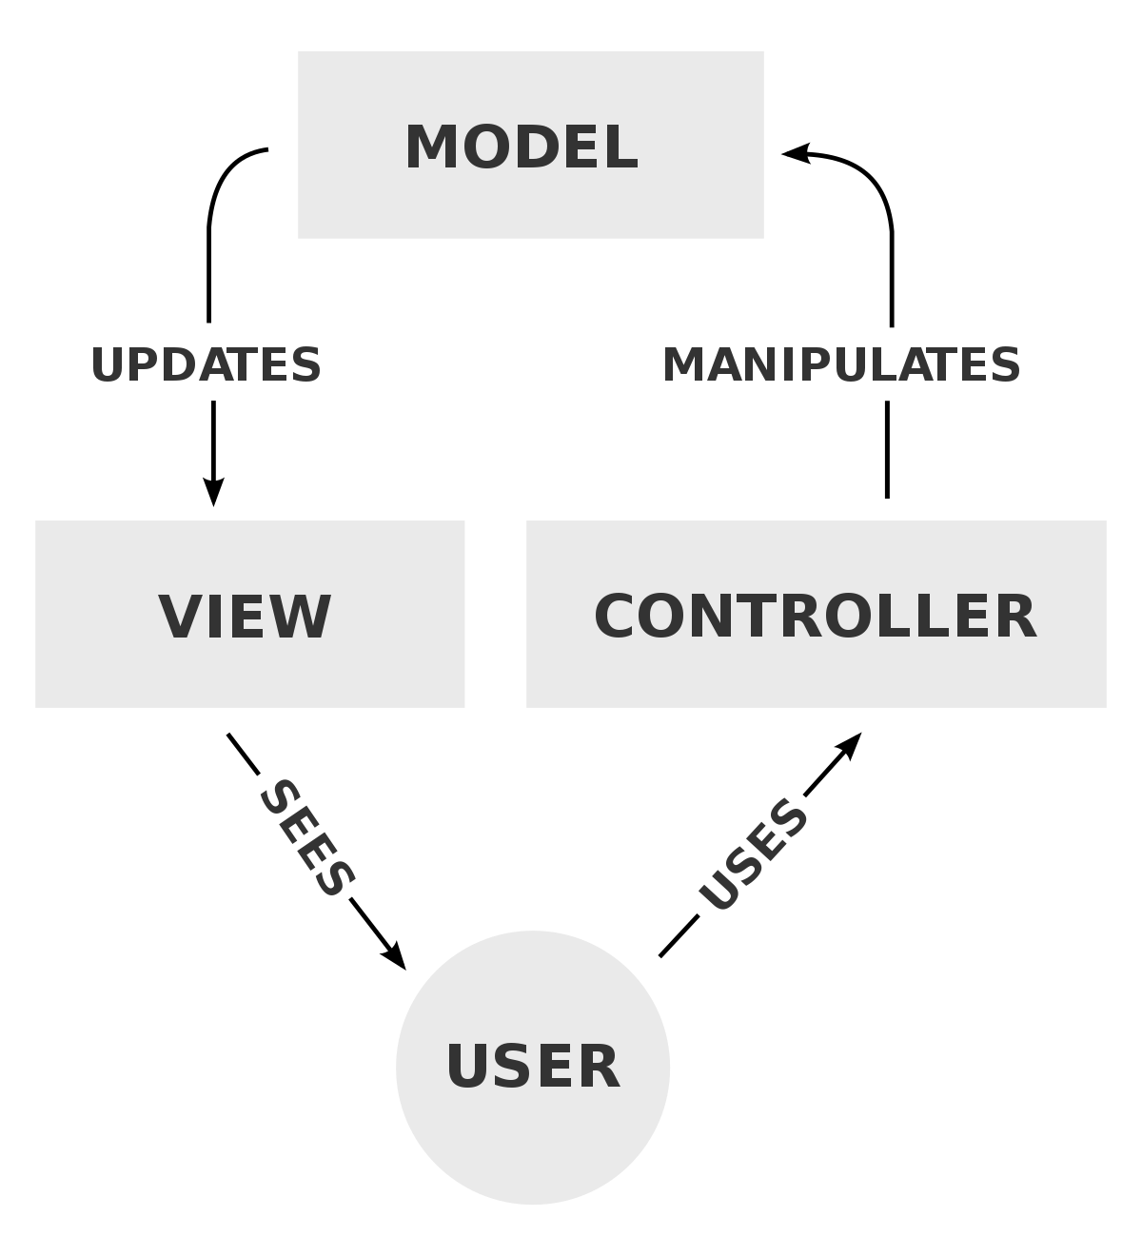

Fig: MVC design pattern

* **Model**

The model handles all the data related logic that user work with. This represent data that is transfer between view and controller.

* **View**

The view handles all UI logic of application.

* **Controller**

Controller acts as transitional between model and view to process incoming requests and logic.

## 2.9 Conclusion: -

During analysis phase, I have done feasibility study in order to find important factors of the project. Than I have gather requirements of the project, which I have divided into two parts functional and non-functional. Later I have used MoSCoW prioritization to divide most important feature to least important. I have designed use case diagram, which help to understand the roles of user and admin, and designed initial class diagram for the project. I have done PEST analysis to handle the different factors of the analysis.

# Chapter-3 Design

## 3.1 Introduction

After the completion of the analysis phase than the design part is start. In this phase, we develop the logical solution with the help of various tools, techniques and models, which will exist in the paper and on the designing tools, which will be implemented on the system as we go on the other project phase. Design phase plays the most vital role on the software development cycle. For this project, some of the models are develop which are listed below as you follow down.

## Tools

Following tools are used to develop my project:.

* Sublime text for coding
* MySQL for database
* Star UML for class diagram, DFD, Activity diagram, sequence diagram
* Visual Paradigm for ER diagram
* Google chrome for running the application.

## 3.2 Structural Model

Structural model is the design module that illustrates how the systems components or the functionality will connect with each other. Class diagram, Data Flow Diagram, ER diagram, model diagram, etc. are the some example of the structural model. For my project in structural model phase, I have design class diagram and DFD.

### **Class diagram:**

A class diagram illustrates the static structure of a system. It provides details about the relationships between classes, objects, attributes, and operations. Classes represent an abstraction of entities with common characteristics. Associations represent the relationships between classes. The class diagram is the primary structure build of object oriented objects. It is utilized for general reasonable displaying of the structure of the application, and for converting structures into codes.

Class Diagram for online Liquor store is below:

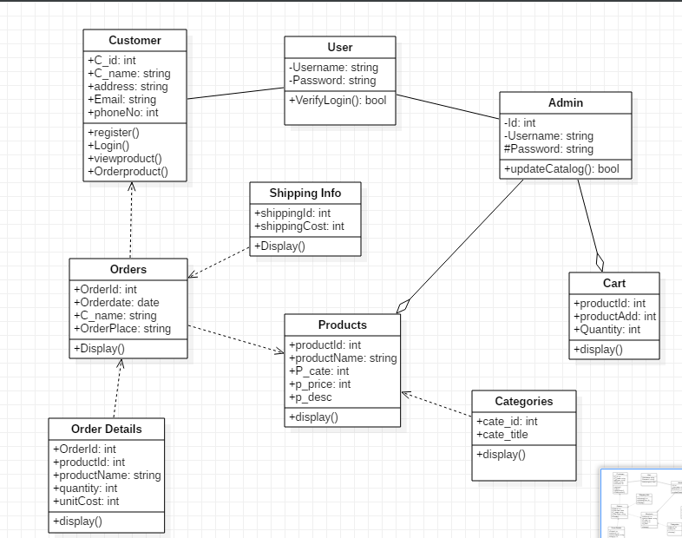

Fig: Class diagram

### Justification

Above class diagram includes important classes for project design. In this customer and admin can abstract user attributes. Order details are dependent in orders. Admin can add, remove products. Admin also can check carts before delivery.

### **Data Flow Diagram:**

An information stream outline (DFD) maps out the progression of data for any system. They can be designed to analysis a current system or model new one. The DFD additionally gives data about the input and output of every entity and the processes. An data flow diagram has no control flow, there are no decision rules and no loops.

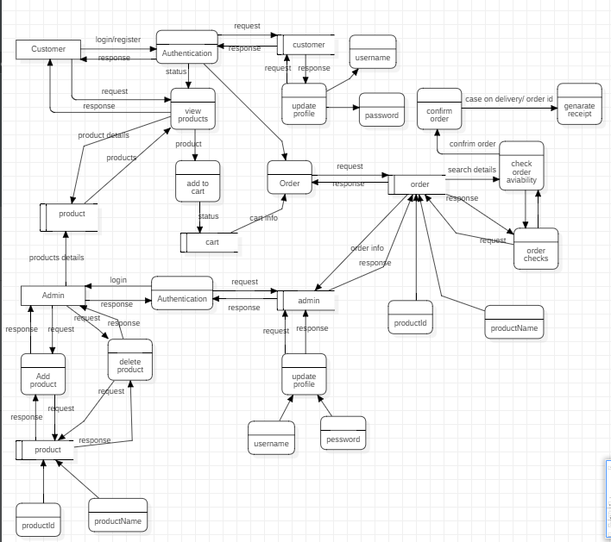

Fig: DFD for online liquor store

### Justification

In this customer can view products without login to the system. Admin have to login before making any changes to the system. DFD provides the working process of the system.

## 3.3 Behavioral Model

Behavioral modeling means utilizing accessible and relevant purchaser and business spending data assess future behavior. Behavioral modeling is utilized by money related foundations to evaluate the risk related with giving assets to an individual or business but at the same time is used in promoting, publicizing, etc.

### Activity Diagram

Activity diagrams are graphical representations of workflows of stepwise actions with help for decision, emphasis and simultaneousness. In the UML, activity diagram are expected to demonstrate both computational and authoritative procedures, just as the information streams converging with the related exercises.

Activity diagram for the project is follow:

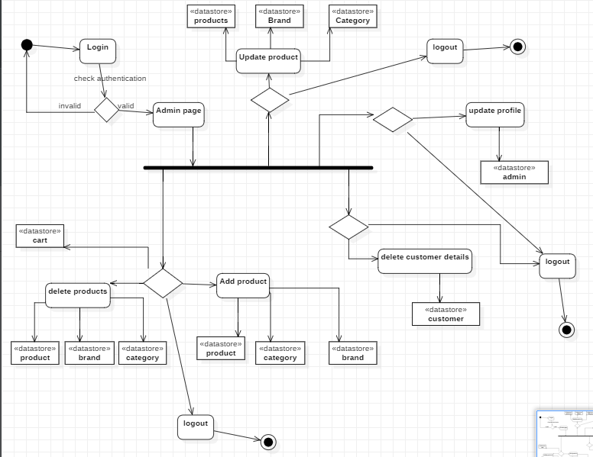

Fig: activity diagram for admin

## Justification

Admin have to login to the system before making any changes to the system. After login admin dashboard is opened then admin can operate the system.

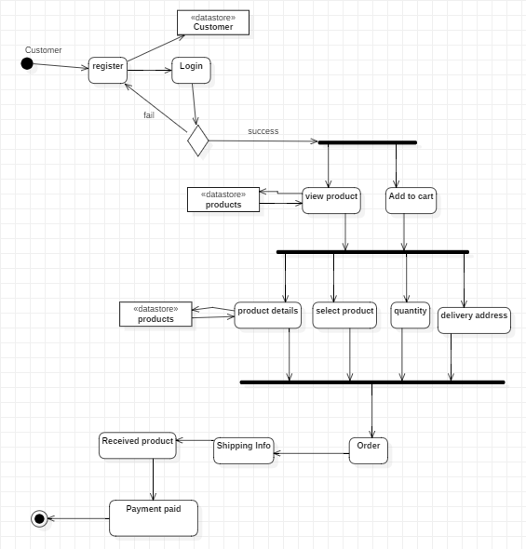

Fig: activity diagram for customer

### Justification

Customer have to register before interacting to the system. They can order the products with entering required details. In the process customer have to pay after the delivery with cash.

## Sequence diagram

Sequence diagrams define relations among classes in terms of an exchange of messages over time. A sequence diagram is a good way to imagine and authenticate various runtime scenarios. These can help to calculate how a system will perform and to discover responsibilities a class may need to have in the process of modeling a new system.

Sequence diagram is also called event diagram of online liquor store is given below:

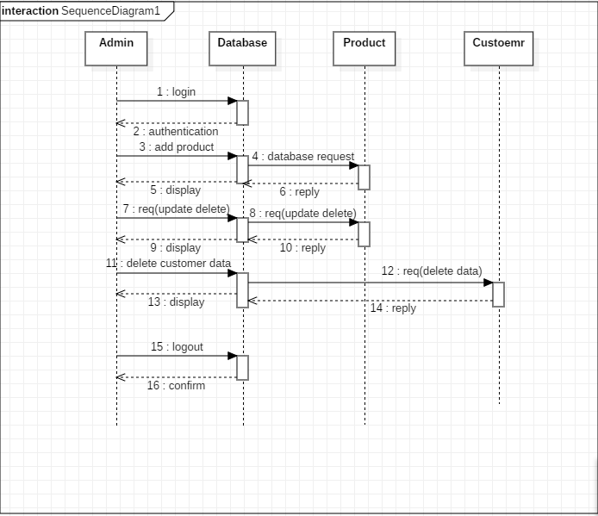

Fig: sequence diagram for admin

### Justification

Above sequence diagram illustrates the actions performed by the admin in the system. Required entities and proper notations are used for the diagram.

Sequence diagram for customer:

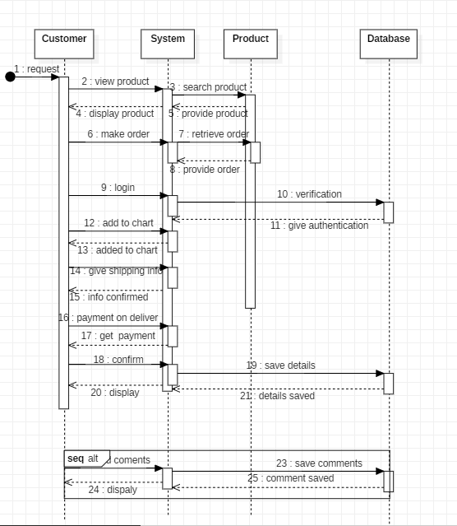

Fig: sequence diagram for customer

### Justification

The above sequence diagram illustrates the process of customer perform in the system. It consists of the messages and replies from the server.

## 3.4 Database

Database is the collection of the data that is managed so that it can be easily accessed, managed and updated. Basically system databases contain combinations of data record such as sales transactions, product catalogs and inventories, and customer profiles.

## Entity Relationship Diagram

An entity relationship diagram (ERD) illustrations the relationships of entity sets stored in a database. An entity in this context is an object, a component of data. An entity set is a collection of similar entities. These entities can have attributes that define its properties.

ER diagram for the online liquor store:

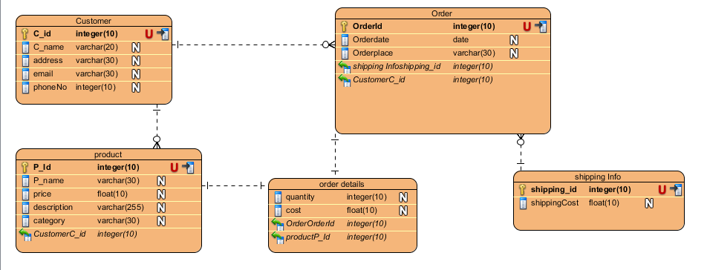

Fig: ER diagram for the online liquor store

## Data Dictionary:

Database tables

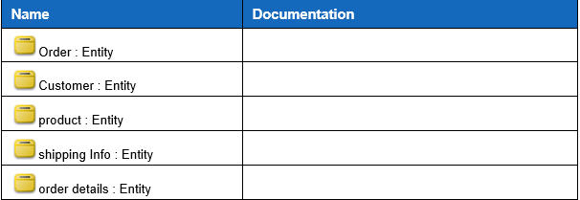

Customer table

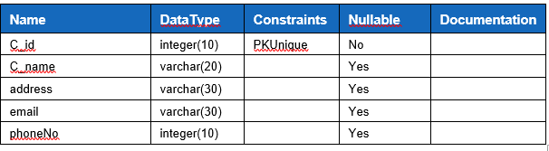

Order table

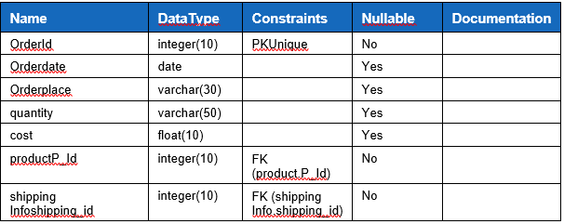

Order details

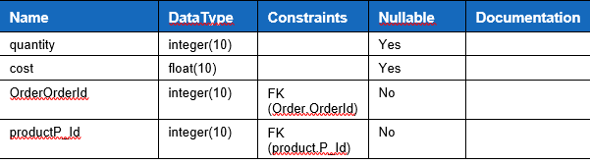

Shipping table

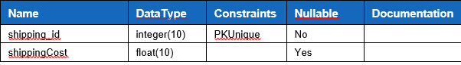

Products table

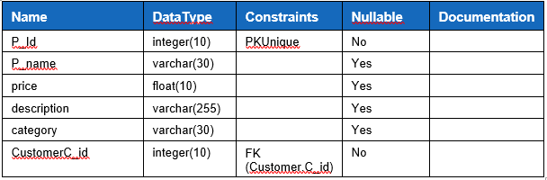

Fig: tables of database

## 3.5 Prototyping

Prototyping is an initial stage of a system development which developmental progress and product solutions may occur before a better release is initiated. These kinds of actions can also sometimes be called a beta phase, where an initial task gets estimated by a smaller class of users before full development of the system.

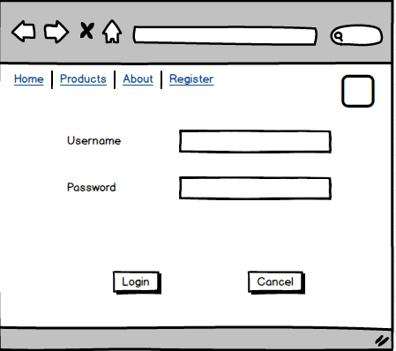

Fig: prototype for login page

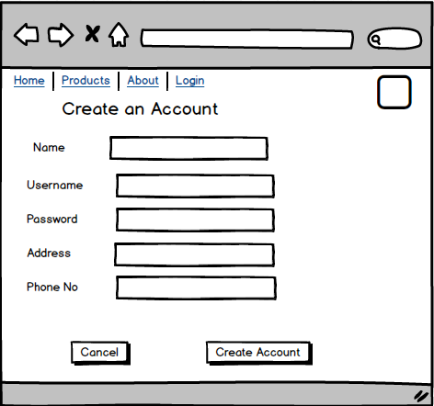

Fig: prototype for register page

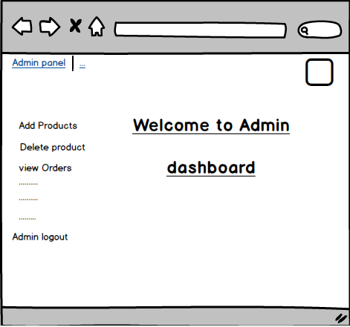

Fig: prototype for admin dashboard

# 3.6 Conclusion

Hence, the design phase of project is successfully completed. All the step of this phase are done with proper search. In this phase all the required diagram are designed with project keeping in mind.

# Chapter 4 Implementation

This phase is meant to be the longest phase of the software development cycle. In this phase, the designs and models will be converted in the codes. This has the real work for the developer. This phase illustrate how the function actually work and how it will be processed. **All the UI and codes are listed in the appendix part.**

## Programming language used

Programming languages are known as the connector between the user and the computer. They permits us to give instruction to the computer that computer understand and process. The languages that instructs the computer are known as the high-level language some of them are java, C++, C#, Python, etc. These programming languages has their unique sets of keywords and syntax by which they interact with computers.



For my project I have used core Php (Hypertext preprocessor). Php is the openly available scripting language that is designed for developing web applications that effectually interact with database. This the free and open language to develop the web based applications. For the storage of data in database I have use My SQL database. JavaScript and ajax are also used for the user-friendly.

**Tools**

Following tools are used to develop my project:.

* Sublime text for coding
* MySQL for database
* Star UML for class diagram, DFD, Activity diagram, sequence diagram
* Visual Paradigm for ER diagram
* Google chrome for running the application.

## Design pattern

In software engineering, a **design pattern** is a common repeatable solution to a commonly occurring problem in software design. A design pattern is not a finished design that can be transformed directly into code. It is a description or template for how to solve a problem that can be used in many different situations.

For this project I have used MVC (Model View Controller) design pattern as it that separates domain/application/business (whatever you prefer) logic from the rest of the user interface. It does this by separating the application into three parts: the model, the view, and the controller.

* **Model**

The model handles all the data related logic that user work with. This represent data that is transfer between view and controller.

* **View**

The view handles all UI logic of application.

* **Controller**

Controller acts as transitional between model and view to process incoming requests and logic.

# Chapter 5 Testing

## **5.1 Introduction**

Testing is the activity performed to make sure that weather actual result match the projected result and to make sure that software is defect free.

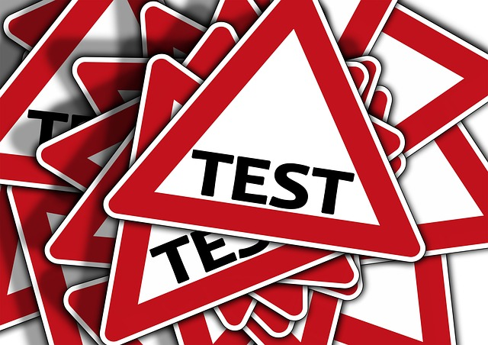

Important of performing testing are:

* Testing saves money and time as if the bug are tested and fixed in initial stage it cost less to fix them.
* It helps to improve the quality of the product.
* It help to identify the problems and threats and remove earlier.
* It brings best user experience possible.

Types of testing’s:

* Black box testing
* White box testing
* Unit testing
* Integration testing
* Beta testing

Among all the testing listed above, I have chosen only two type of testing and they are

* Black box testing
* Unit testing

## 5.2 Black box testing

Black box testing is the testing technique that only focuses on giving the input and producing the excepted results and it ignores the internal code implementation of the system.

By choosing black box testing, we can test the project by only focusing on inputs and outputs not knowing the internal code implementation of the system.

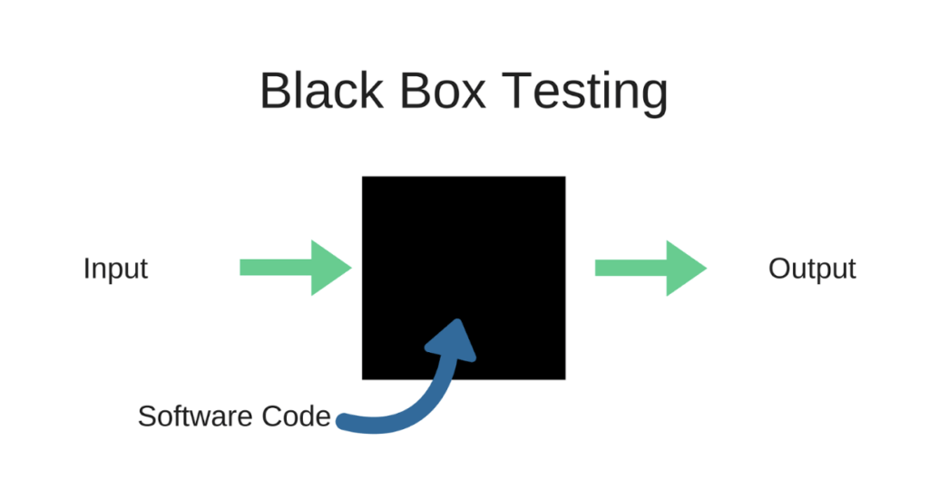

**Test cases**

1. **Test Name: Registration testing**

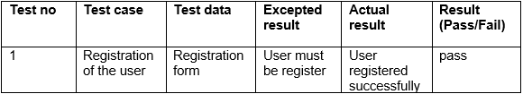

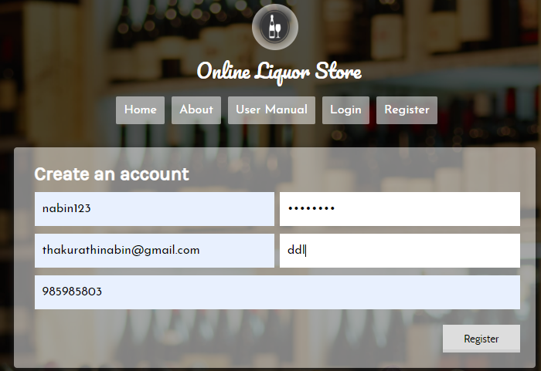

Fig 1: user registration

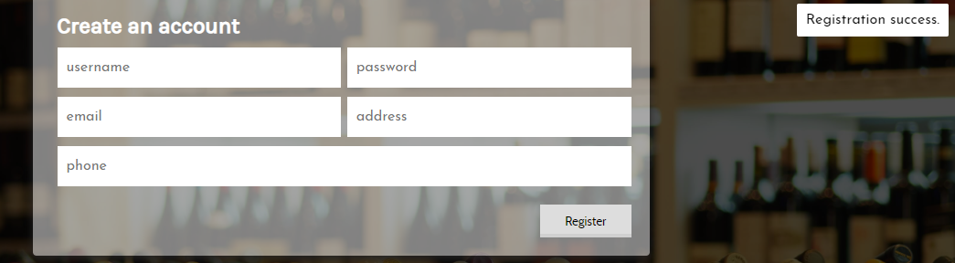

Fig 2: user registration successful.

1. **Test Name: Login test**

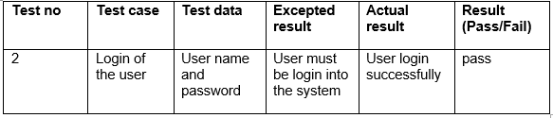

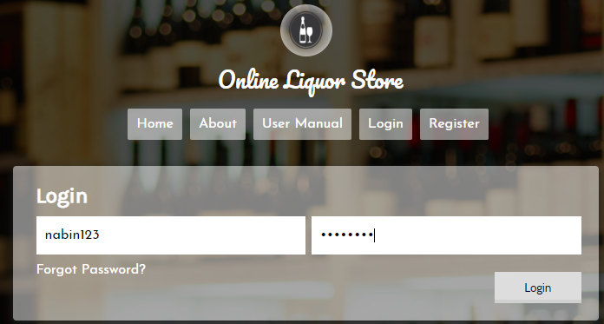

Fig 3: user login form

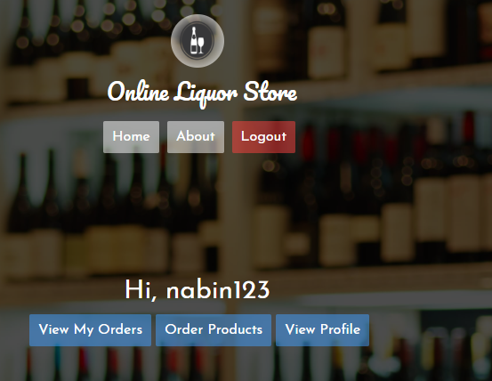

Fig 4: user login successful.

1. **Test Name : forget password**

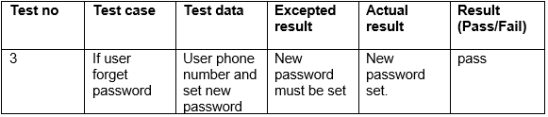

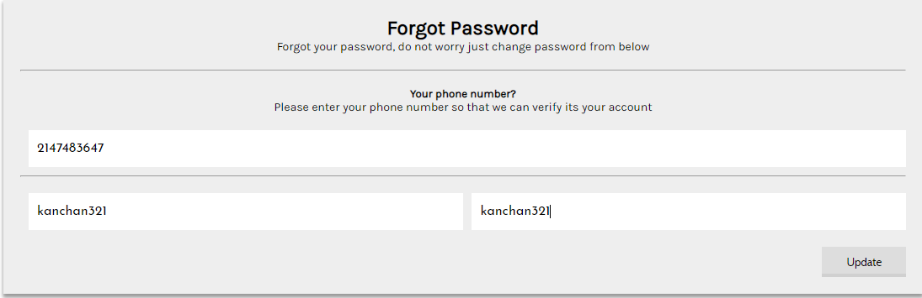

Fig 5: set new password

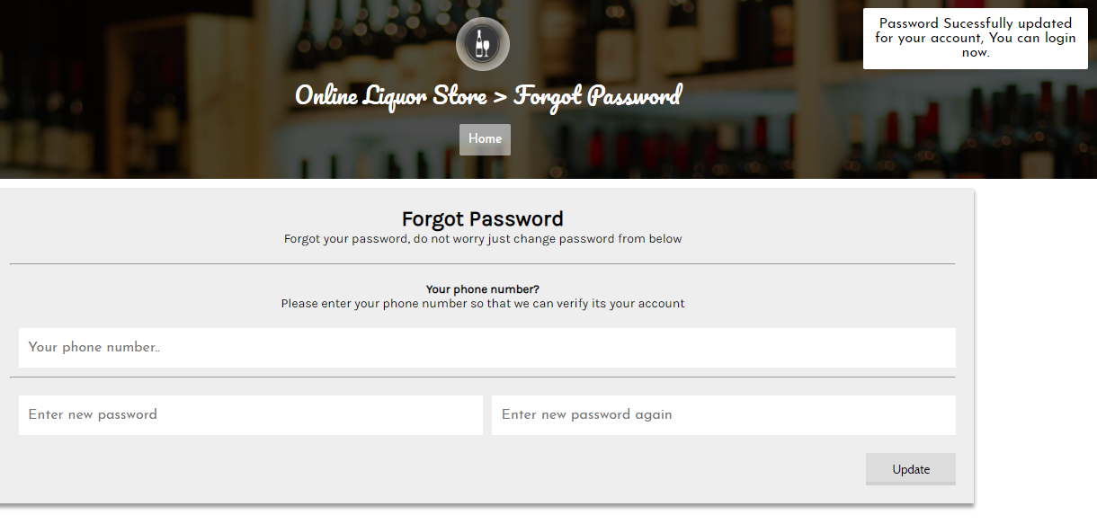

Fig 6: new password updated.

1. **Test Name : Admin Login**

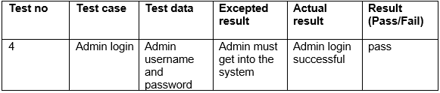

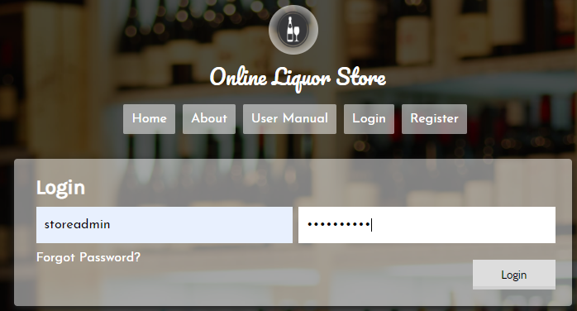

Fig 7: admin login

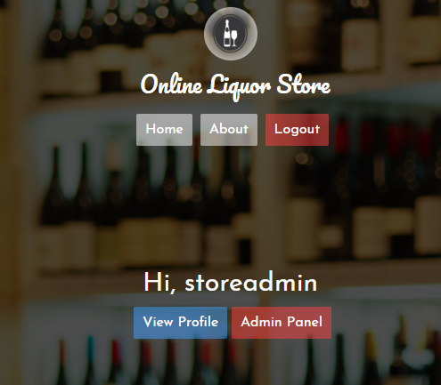

Fig 8: admin login successful.

1. **Test Name : User profile edit**

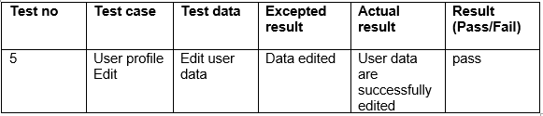

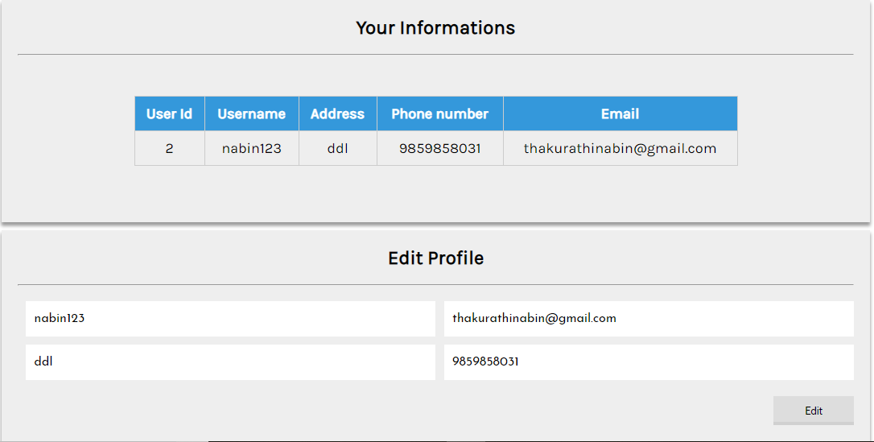

Fig 9: user details.

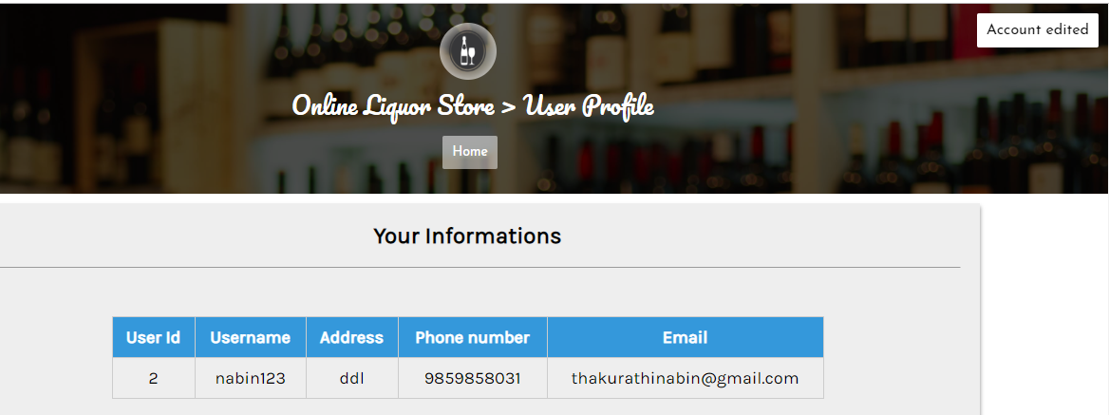

Fig 10: user account edited.

1. **Test Name : order products**

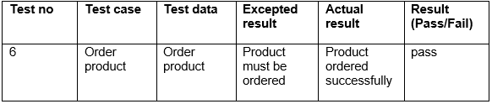

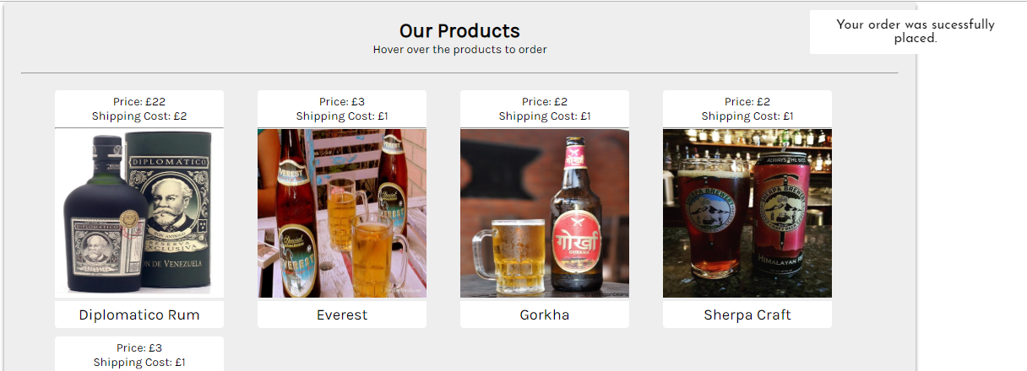

Fig 11: product ordered successfully.

1. **Test Name : View order**

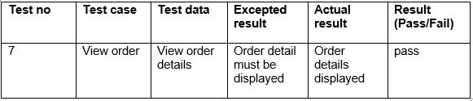

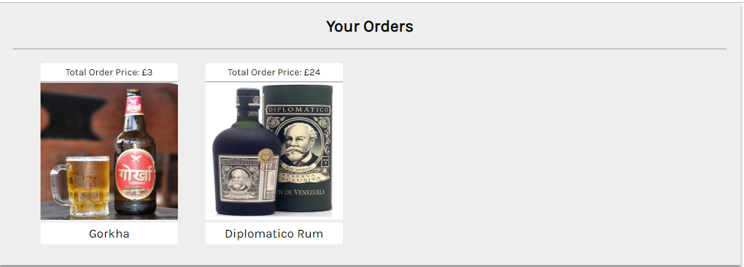

Fig 12: view customer orders.

1. **Test Name : Add product by admin**

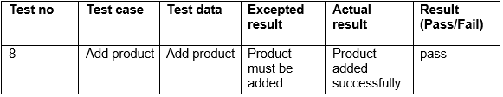

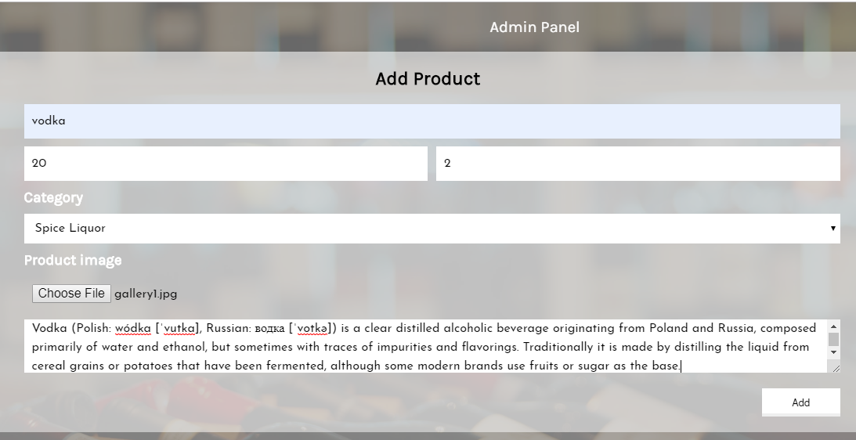

Fig 13: adding product by admin

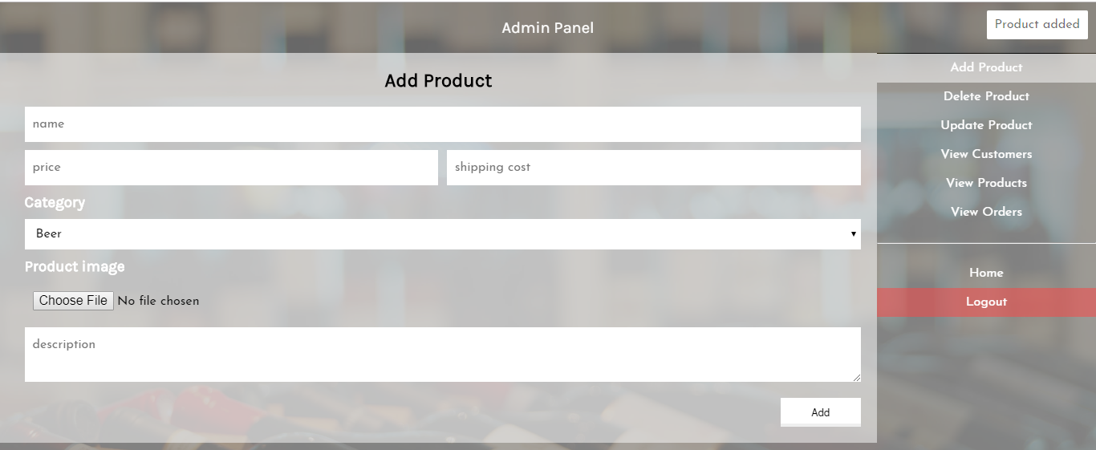

Fig 14: product added successfully.

1. **Test Name : view product details by admin**

As admin need product id to delete the product so he need to view product details before delete.

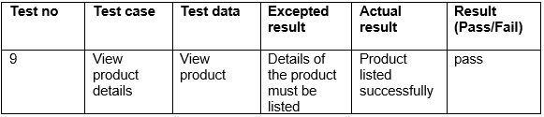

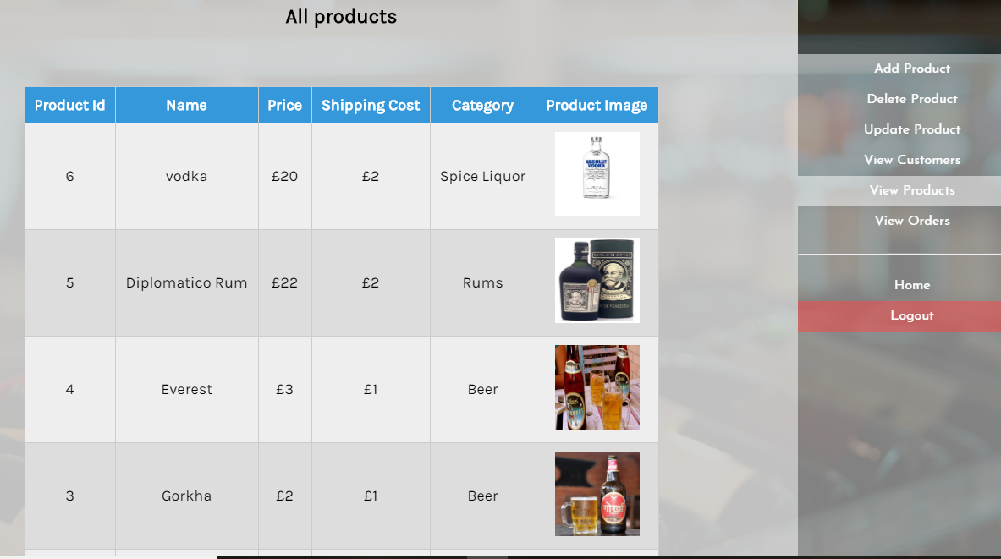

Fig 15: product details are displayed successfully.

1. **Test Name : Delete product**

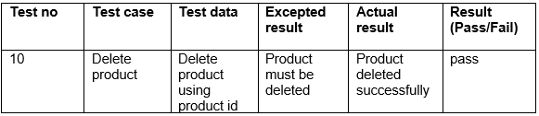

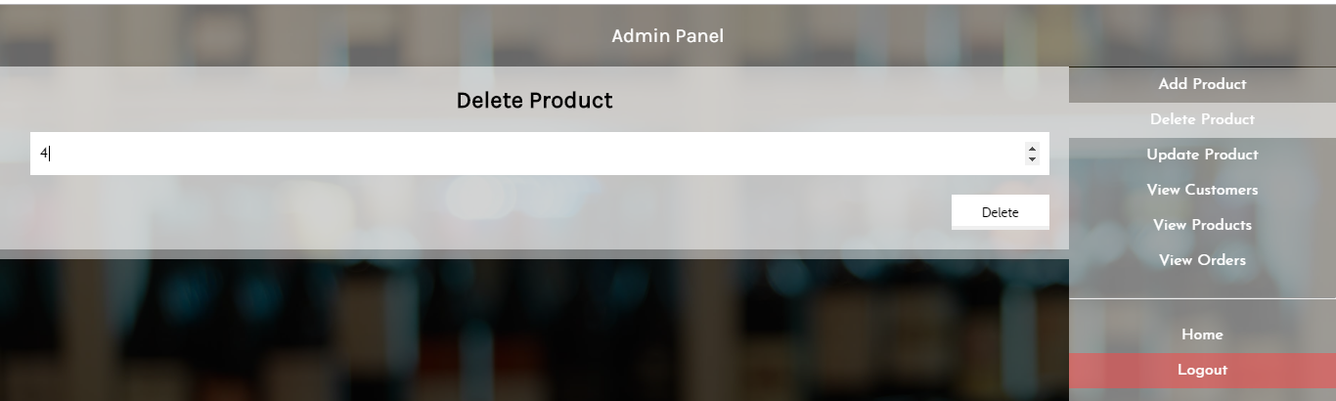

Fig 16: deleting product using product id.

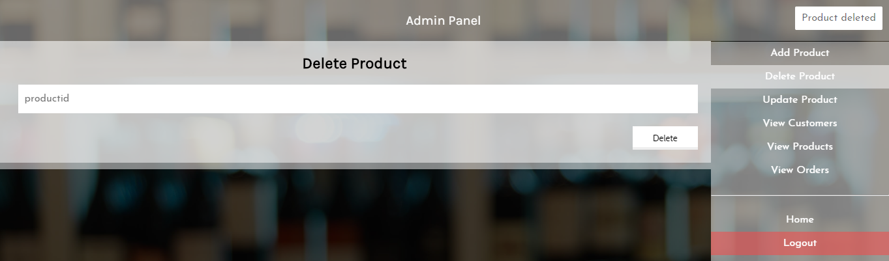

Fig 17: product deleted.

1. **Test Name : update product**

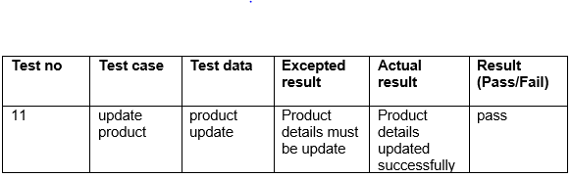

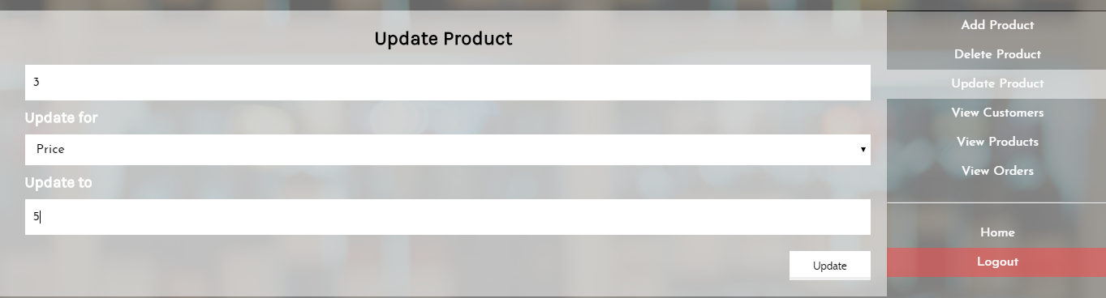

Fig 18: updating product by using product id.

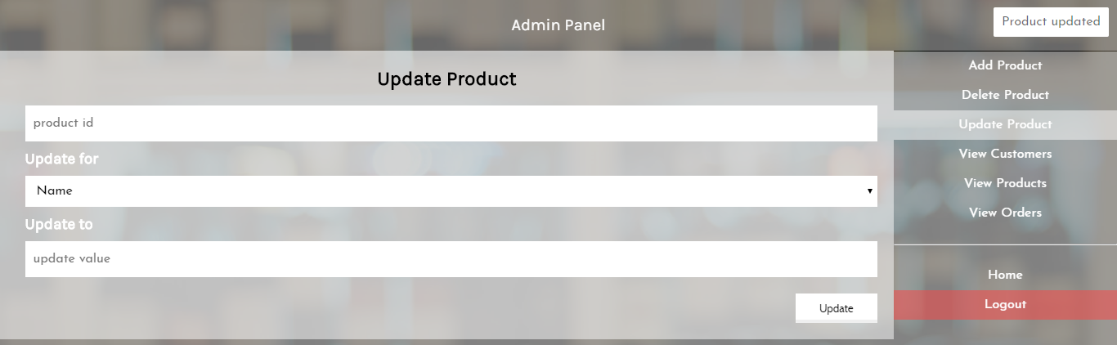

Fig 19: product updated.

1. **Test Name : customer details view by admin.**

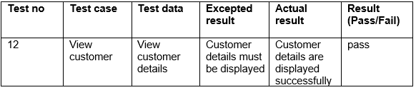

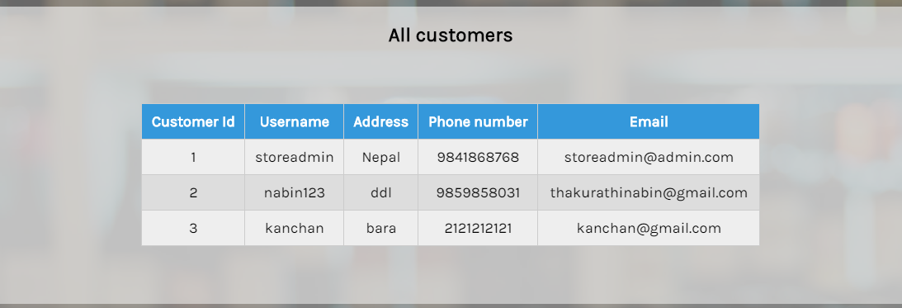

Fig 20: customer details displayed by admin.

1. **Test Name : order viewed by admin**

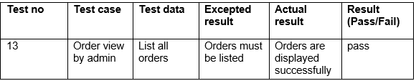

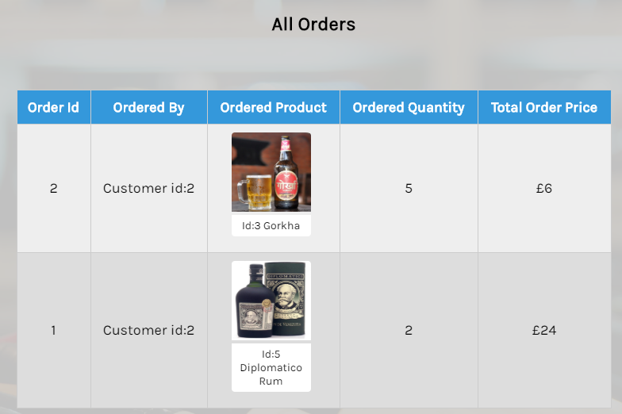

Fig 21: order details.

1. **Test Name : testing invalid password.**

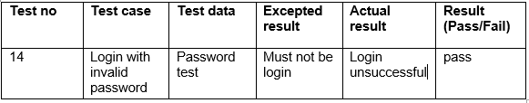

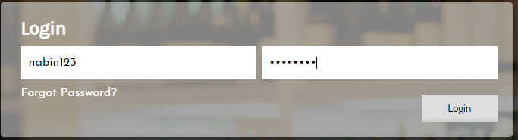

Fig 22: Entering invalid password

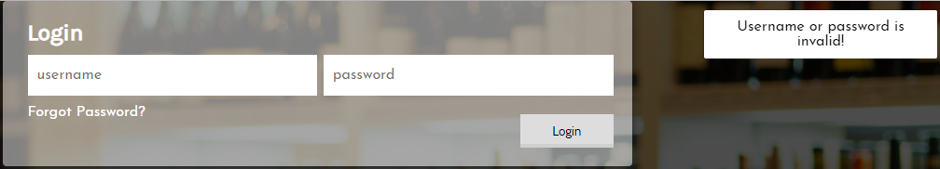

Fig 23: password is invalid.

1. **Test Name : registration with incomplete details.**

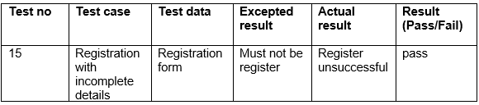

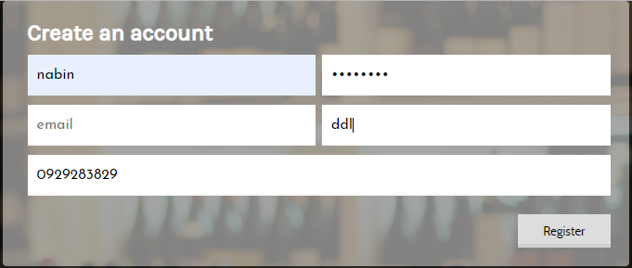

Fig 24: entering details to register.

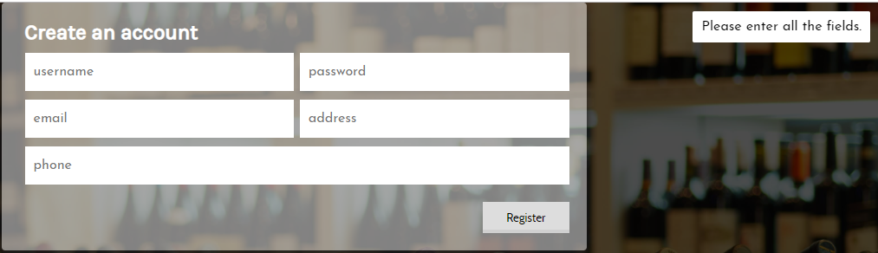

Fig 25: registration unsuccessful.

## 5.3 Unit testing

Unit testing is known as the type of software testing in which particular units or components are tested. Unit testing is done during the implementation of coding in the system.

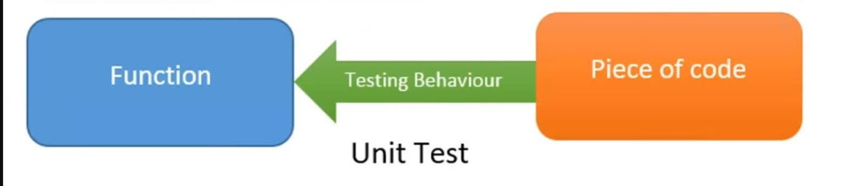

Fig: unit testing.

1. **Test Name : login test**

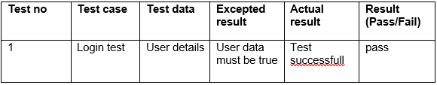

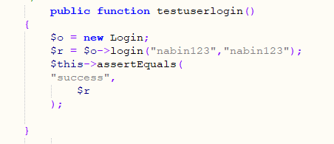

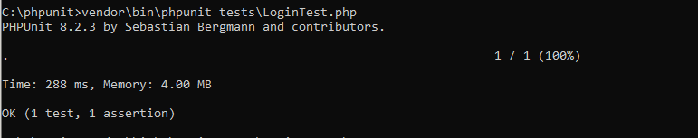

Fig: login test

1. **Test Name : registration test**

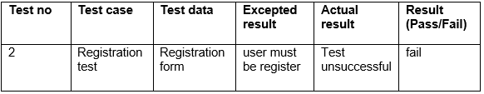

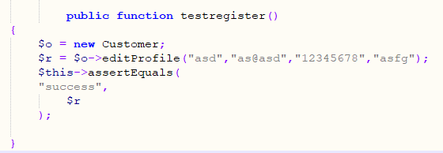

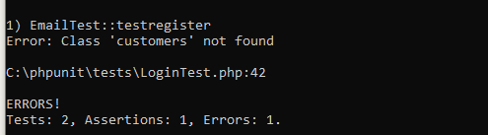

Fig: registration test

1. **Test Name : registration test**

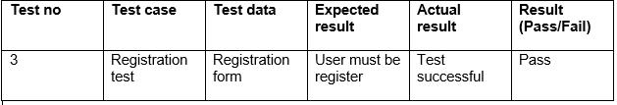



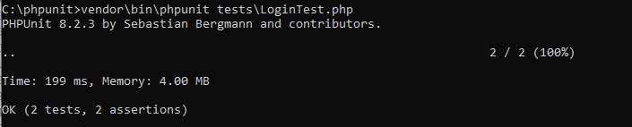

Fig: registration pass result

1. **Test Name : forget password test**

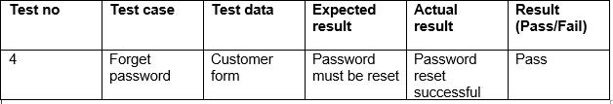

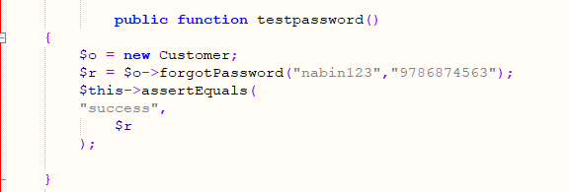

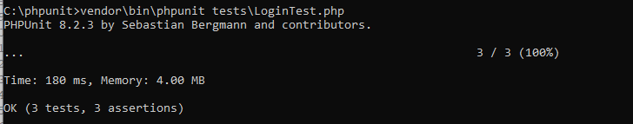

Fig: forget password test

# Chapter 6 other project issues

## 6.1 Risk management

During the process of software development, many obstacles delay the development process. Many risks have to be solved in this development process. Identifying the risk and finding the measures are the most essential factors to be executed for any project to be completed successfully. The project risks are also known as the potential problem in the project development process, which may increase the cost, time and skilled man, power to overcome them. In the case of software management, the risk management refers to the identification of the risk, ways to manage risks and method applied to control them. There are three main steps for risk management:

* Identification of the risk:

This is the initial phase of the risk management session. In this phase identification of the possible risk are done which may affect the software development. For the identification of the risk that the project may face than best way is that to analysis the problem faced by the previous project.

* Analysis of risks:

This stage of the risk management of the most important stage. In this stage, identified risks are categorized on the basis of impacts, likelihood and the level all are analyzed in this stage.

* Risk control:

The third and last stage is risk control. In this stage different method are applied to manage or control risk that the analyzed. By applying the methods and processes some risk are manage and are removed quickly.

To identify the impact of the risk on the project following ways are used.

**Impact = likelihood * Consequences**

Likelihood table

|  |  |
| --- | --- |
| **Likelihood** | **Values** |
| Low | 1 |
| Medium | 2 |
| High | 3 |

Consequences table:

|  |  |
| --- | --- |
| **Consequences** | **Values** |
| Very Low | 1 |
| Low | 2 |
| Medium | 3 |
| High | 4 |
| Very high | 5 |

## Risks arises during the project, their impacts and the solutions are listed in the below table:

|  |  |  |  |  |  |
| --- | --- | --- | --- | --- | --- |
| **SN** | **Risk** | **Likelihood** | **Consequences** | **Impact** | **Remarks** |
| 1. | Low experience | 2 | 4 | 8 | Low experience may cause the beginning of the project slow. |
| 2. | Insufficient time | 2 | 3 | 6 | Insufficient time leads to the incomplete in implementing the all features and testing. |
| 3. | Continuous arise of bugs and errors | 3 | 3 | 9 | Bug and error appear and disappear delay the other phases such as testing. |
| 4. | Software failure | 2 | 3 | 6 | Software failure leads to the delay in the deployment process. |
| 5. | Insufficient resources | 2 | 3 | 6 | Lack of resources leads to increase I time and cost. |
| 6. | Data loss | 2 | 4 | 8 | Data may be lost by many reasons so backup is important. |
| 7. | Improper scheduling | 2 | 3 | 6 | Proper scheduling must be done after the proper analysis of the project. |

## 6.2- Scheduling of the project.

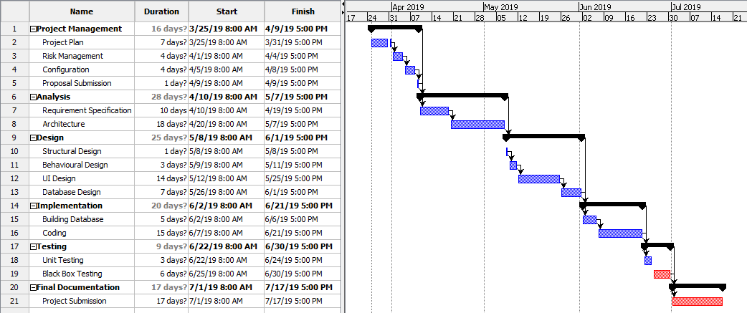

Fig: final Gantt chart

## 6.3 Configuration management

Configuration management is the process of tracking the hardware, software and other related information of the system. Configuration management is a systems manufacturing process for establishing and maintaining consistency of a product's performance, functional, and physical attributes with its requirements, design, and operational information throughout its life. Configuration tools can reduce the outage caused by production change and help to improve the projects change impact analysis. In the process of configuration management I have also manage GitHub for this project ae the part of version control.

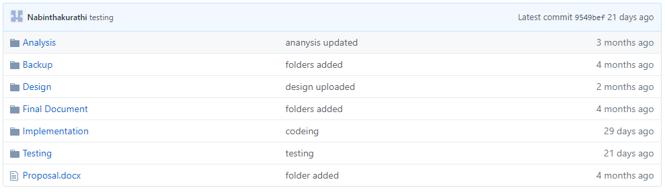

Fig: GitHub for online liquor store.

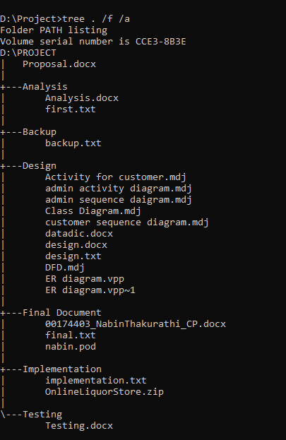

Fig: tree structure.

## 6.4 Future work

Future work does not indicates the present project is incomplete. This project is completed with the basic and important feature of the application. As this project is small college based project so the all the advanced features are not included. Also with the time limit all, the features that are stated in the proposal are not able to include. There are some important feature are to be included in the application to stay in the business and that all remaining features will be included as fast as possible. New feature will also be introduced by the time, which are not included in the proposal. Some the future work, which are included in the proposal, are:

* Online payment system will be added in the system.
* Review provided by the customer for the products
* Rating system
* Feedback of the customer for the service or in the case of delivery.
* Some advance security measured will be applied.

## 6.5 User manual to Online Liquor store

As the new customer may it find difficult to operate the system so the following user manual is develop:

* **Following are the steps for the registration.**

Step 1: click on register.

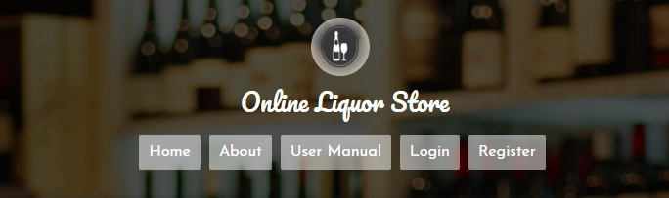

Step 2: Fill all the details than click on register button. After this you are register to the system.

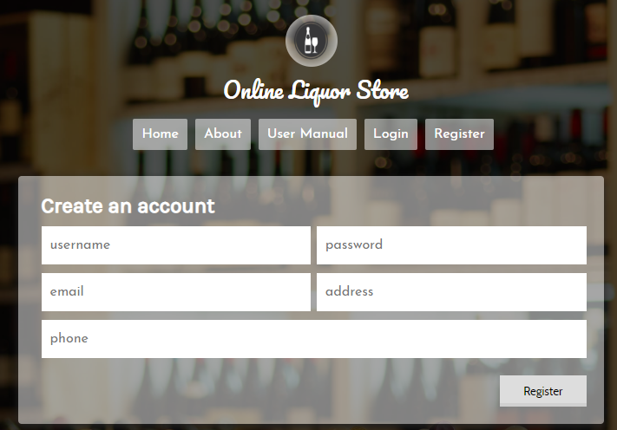

* **Steps to login into the system after registration**

Step 1: click on login button.



Step 2: enter your username and password than click on login into the system.

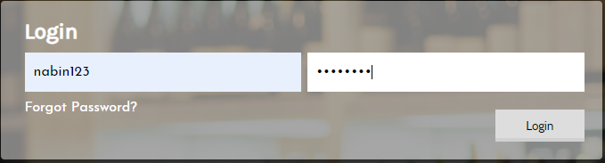

Click on forget password

* **Steps in case you forget your password.**

Step 1: click on forget password.



Step 2: then below page open and change your password on the basis of phone you enter on your details during registration. Then click on update.

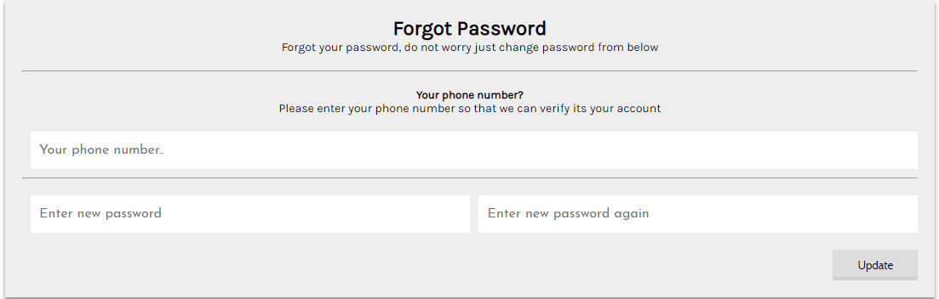

* **Steps for ordering the product.**

Step 1: After login, this window will open and click on order products.

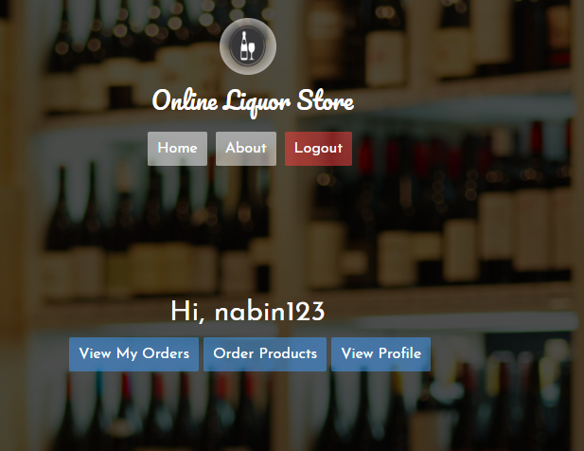

Step 2: product will be displayed and click on the product image than you will have to enter the quantity you want to order. After that click on Order button.

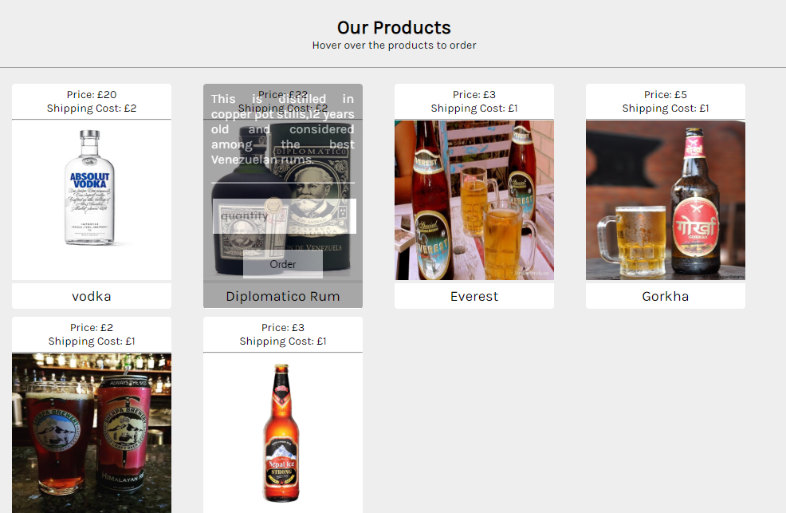

* **Steps to view orders**

Step 1: click on view my order button.



Step 2: than the order page will open

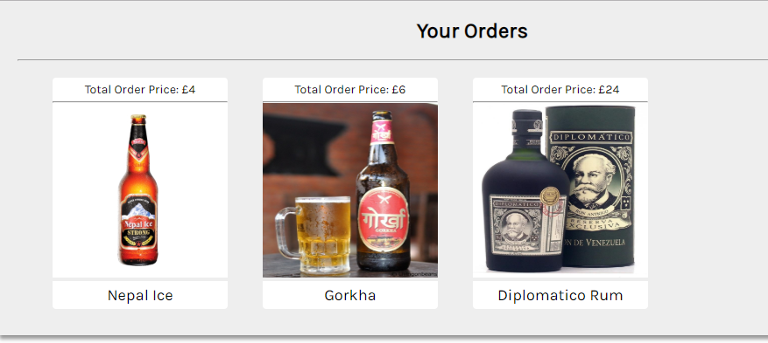

* **Steps to edit the details of your profile.**

Step 1: click on view profile button after login



Steps 2: enter your details you want to edit. Then click on edit button.

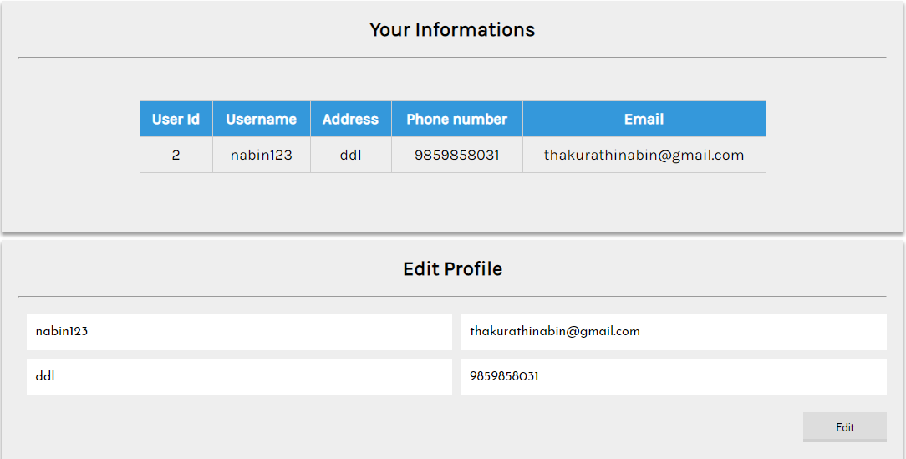

## 6.6 Limitations of the project.

As the project is for the basis college based assignment, there are some feature that are not included some are due to time limit and some are because of lack of experience in this field. Here are some the limitation of the project:

* Online payment system is not included this time but is the part of the future work.
* Review system
* Feedback from the customers about the product and service.
* No display of the upcoming products.

# Chapter 7 Conclusion of the project.

This project was started as the sample of the online business ideas that are rapidly increasing nowadays. For the development, this project waterfall methodology was used. Under this methodology all, the requirements are analyzed and prioritized. Than the requirements are prioritized based on Moscow prioritization. Different designed were developed and prototyping also done. Designs such as class diagram, DFD, sequence diagram, etc. were also been developed. In the implementation phase, all the designed were converted into codes and the database was also created by using different tools such as sublime text for Php coding. Testing was also performed to test the functionality of the system. Black box and unit testing were done for this project.

Online liquor store is the web-based application that will sell different kinds of drinks online. In this system you can view the product but for ordering you must register to the system than only you can login into the system and order the product as you wanted. You can edit your information on this system. This application is developed by keeping best user experience in mind.

# Chapter 8 Appendix

Implementation of the project are listed below:

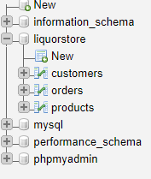

Fig: Tables of Online liquor store system.

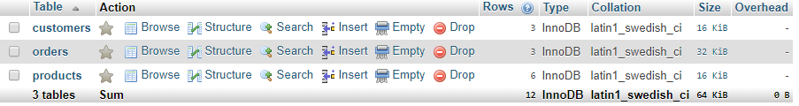

Fig: Database table of the system.

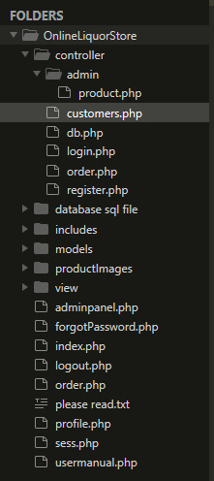

Fig: project PHP files.

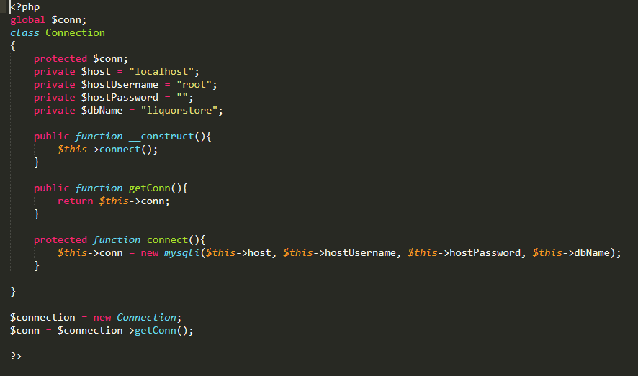

Fig: DB connection

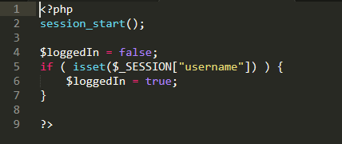

Fig: session control.

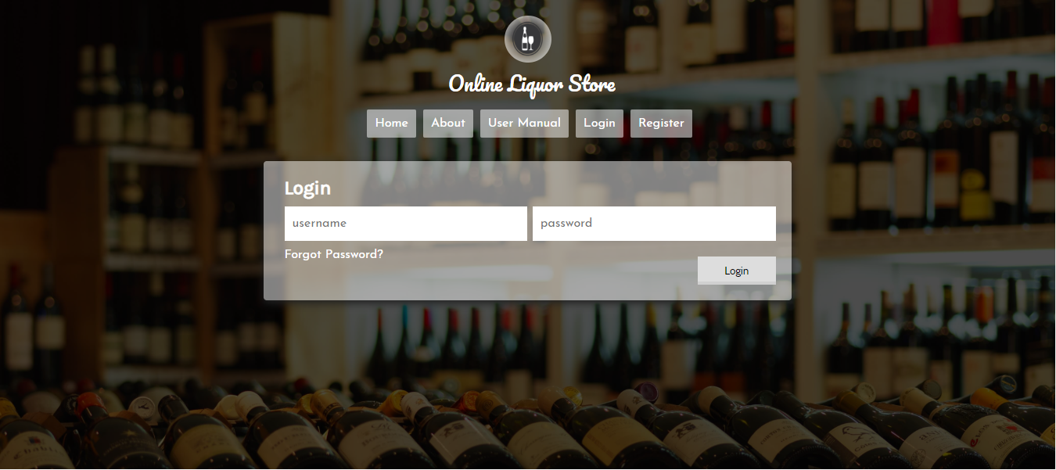

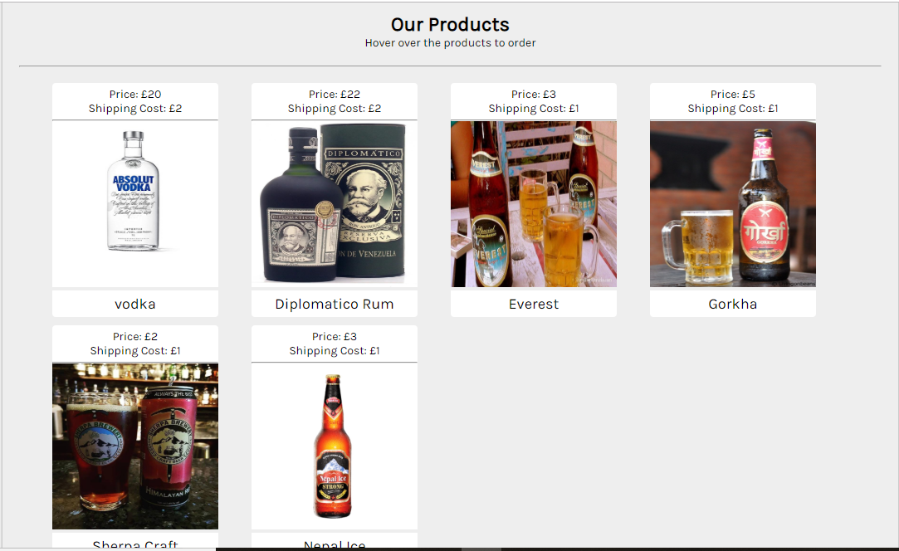

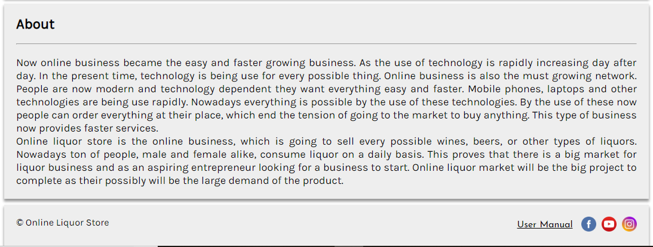

Fig: home page.

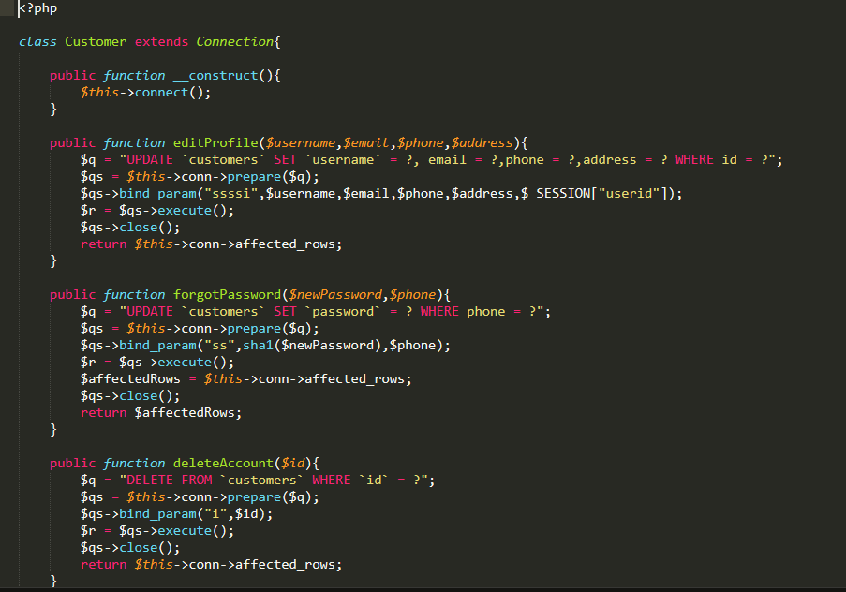

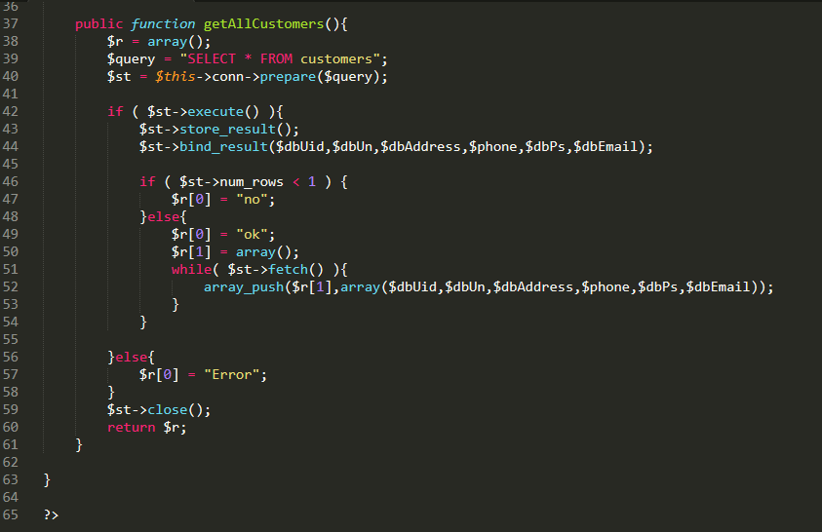

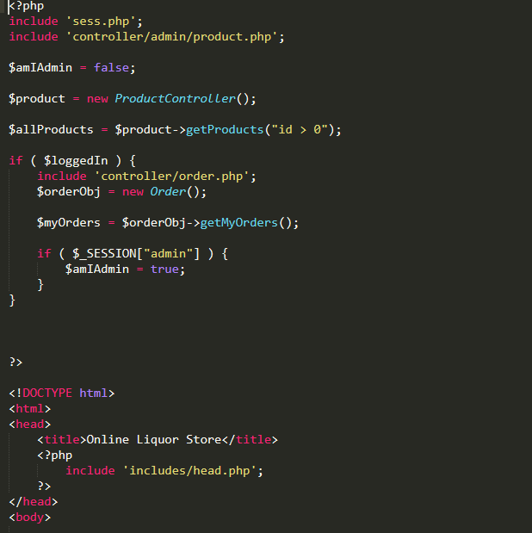

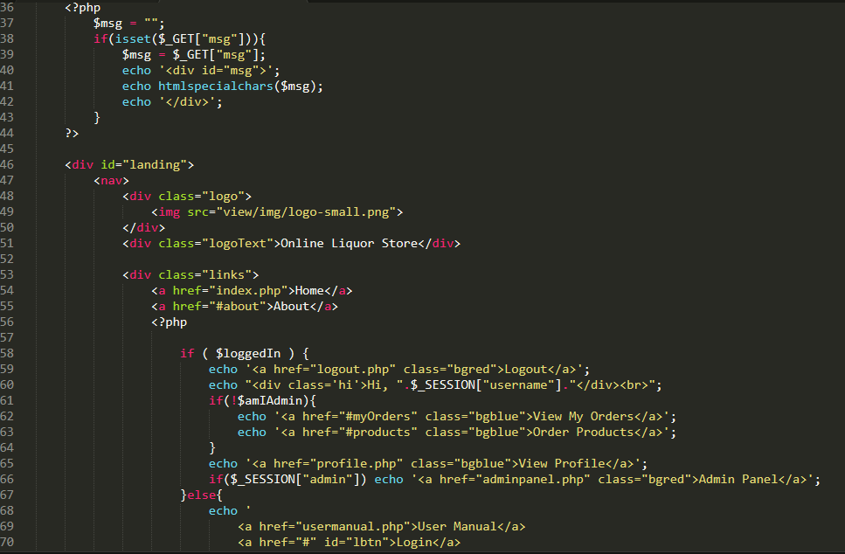

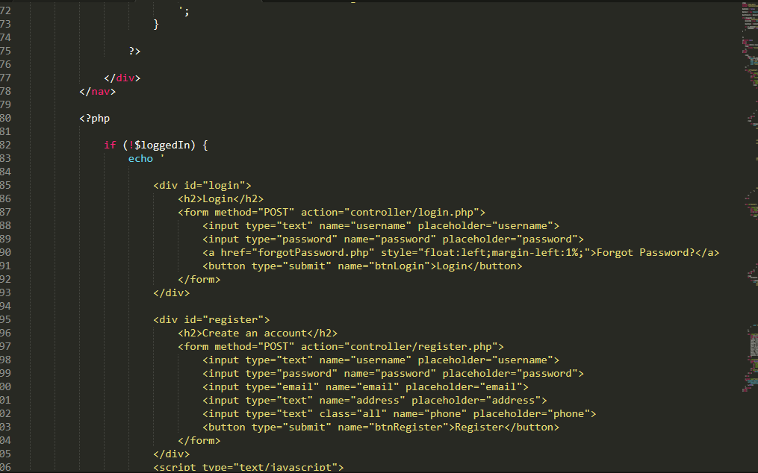

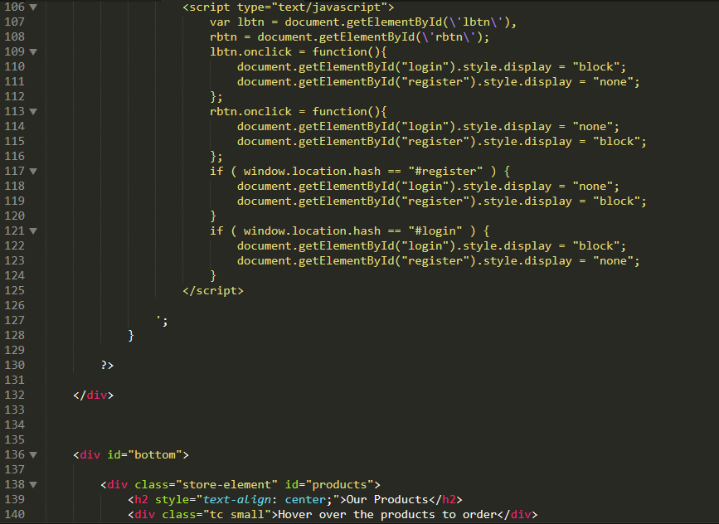

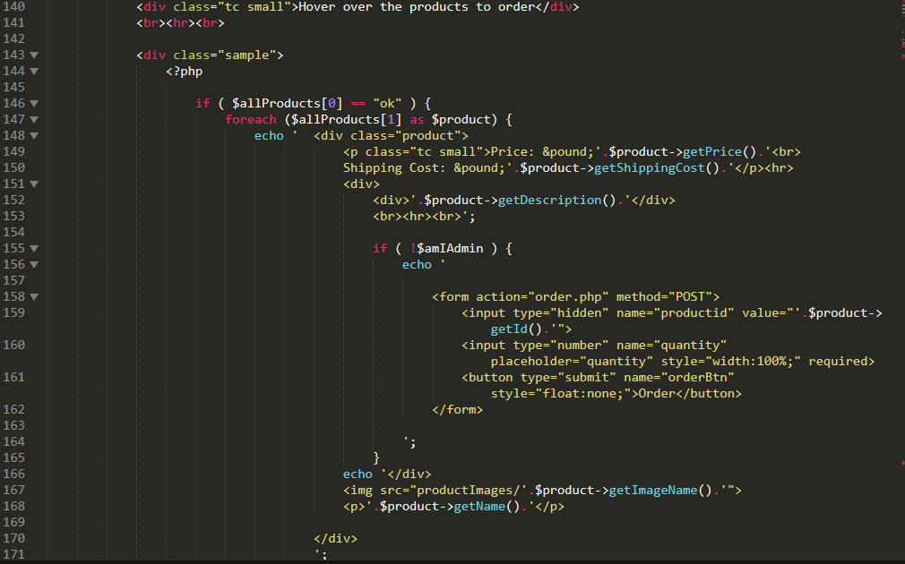

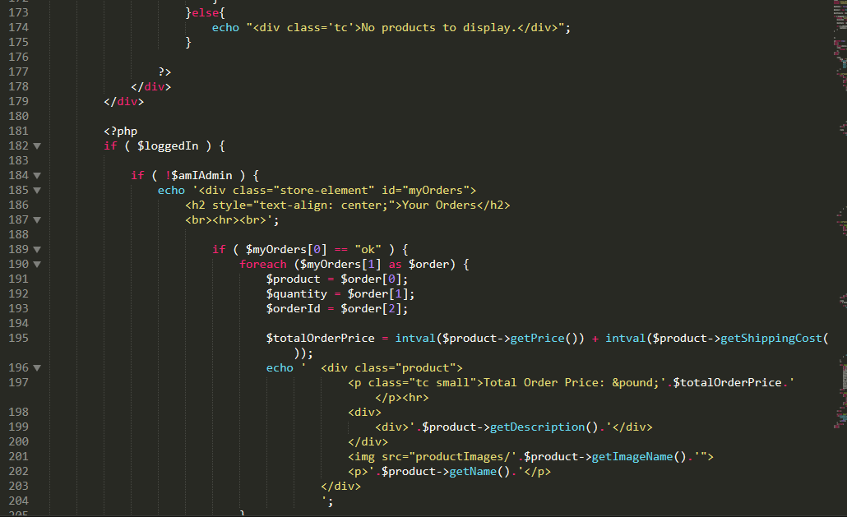

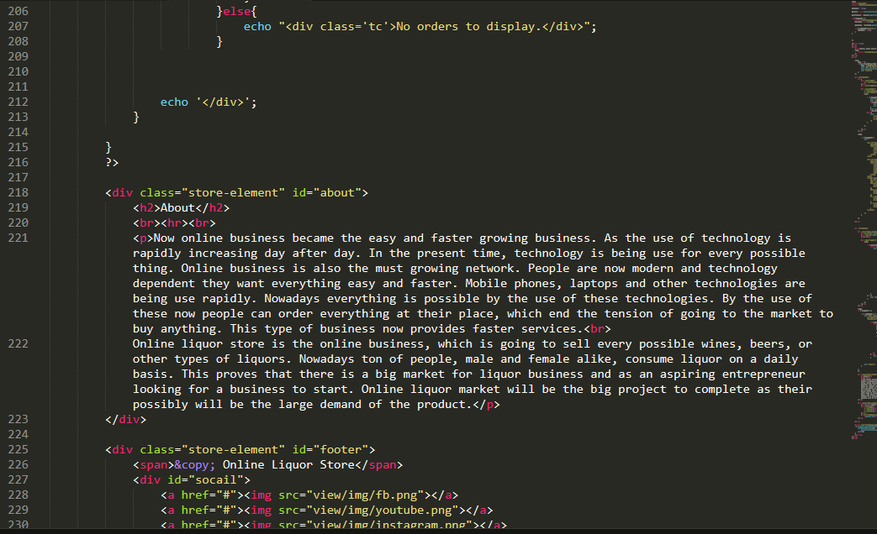

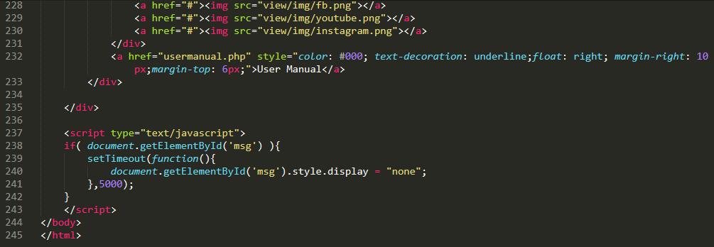

Fig: codes of home page

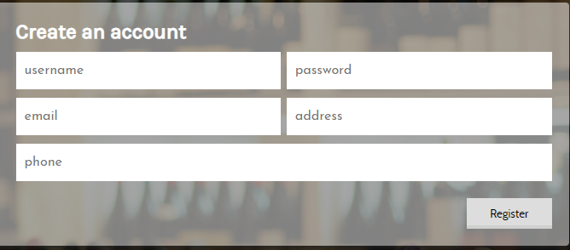

Fig: register form.

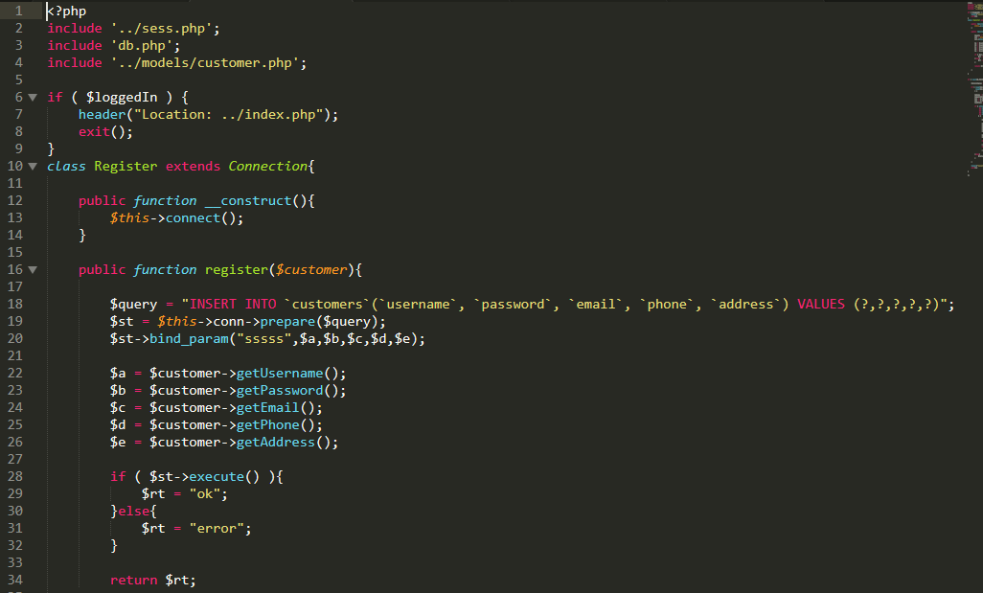

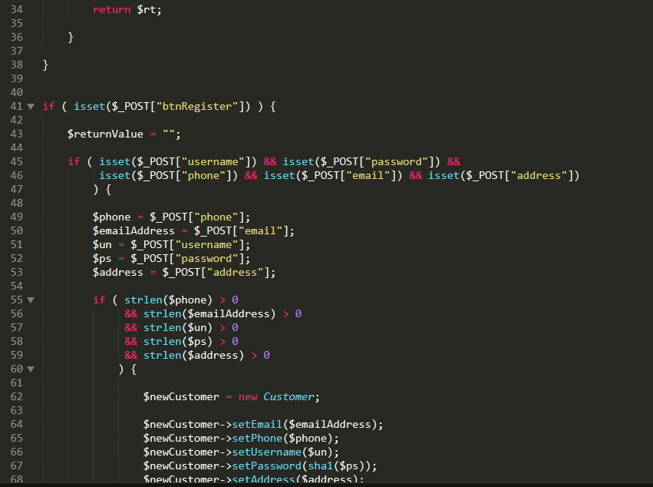

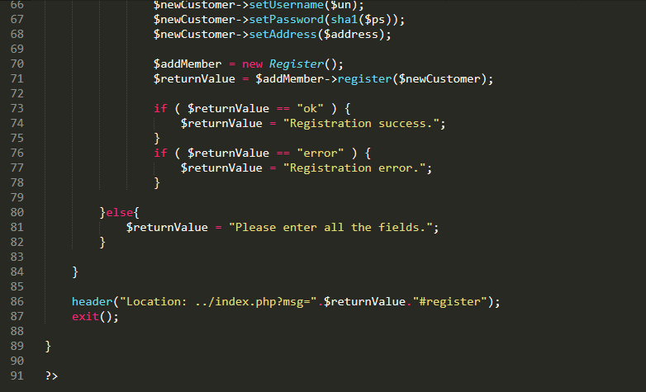

Fig: codes of register.

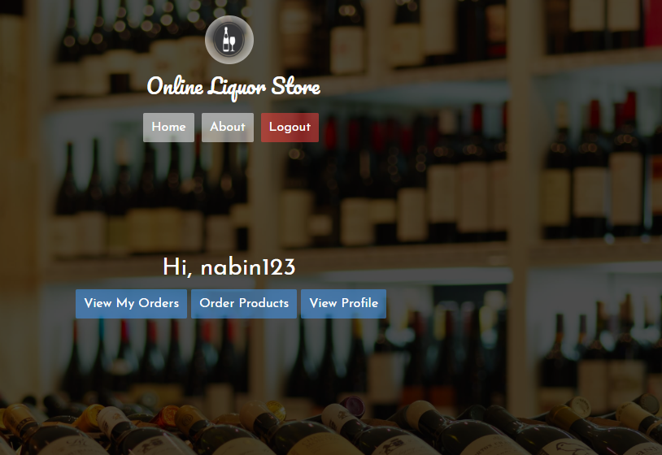

Fig: login page

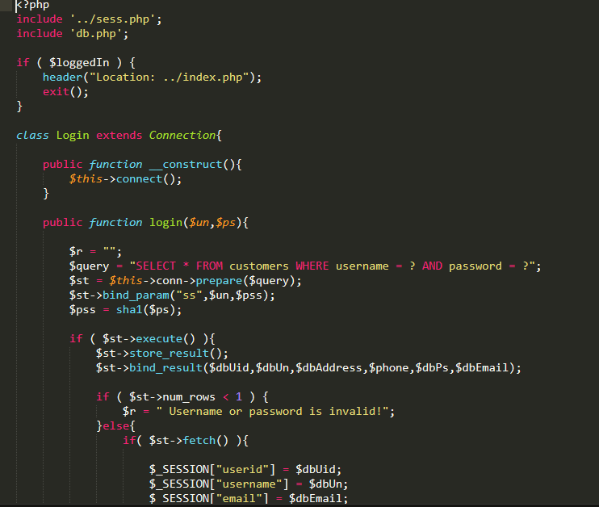

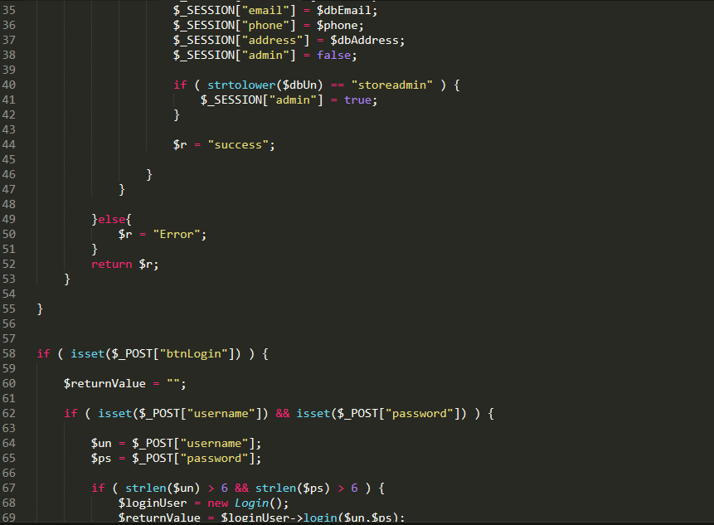

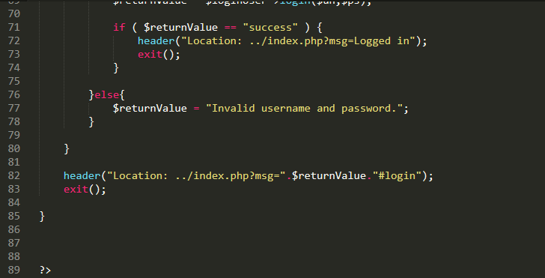

Fig: codes for login

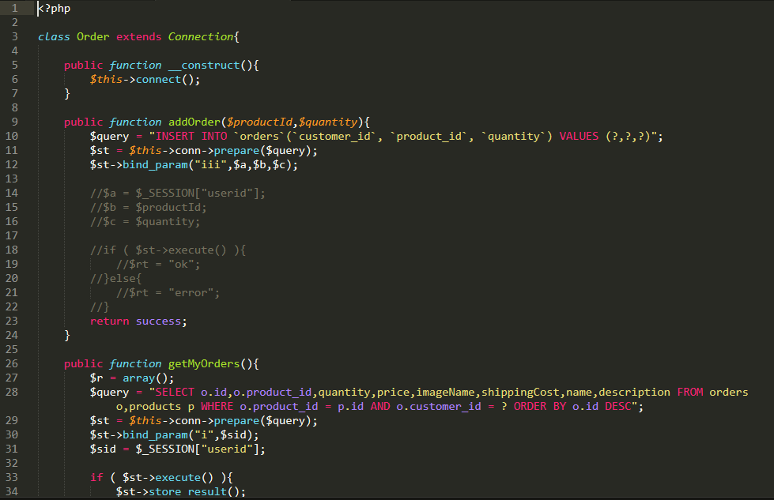

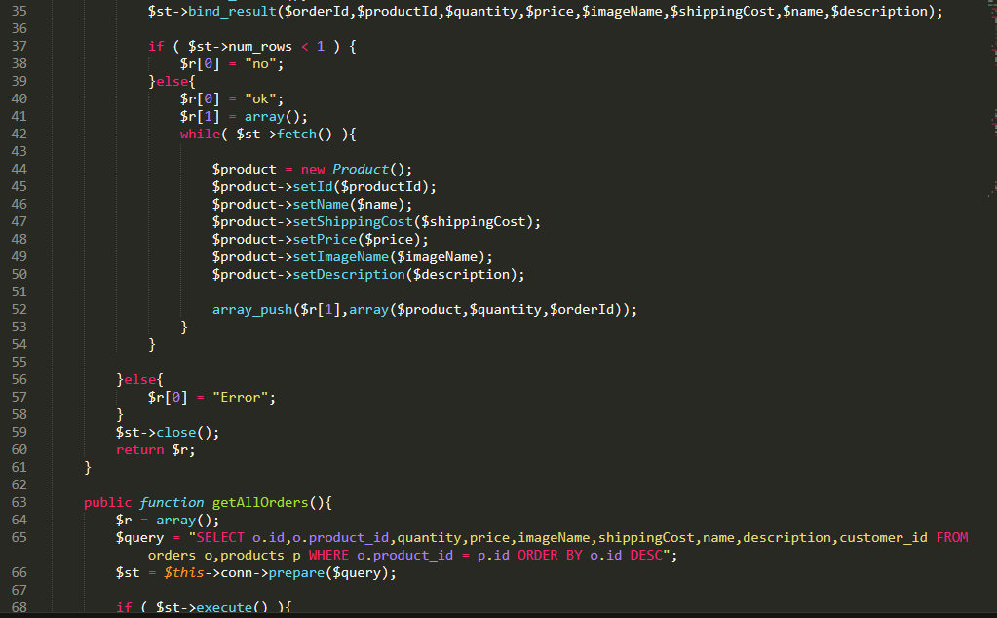

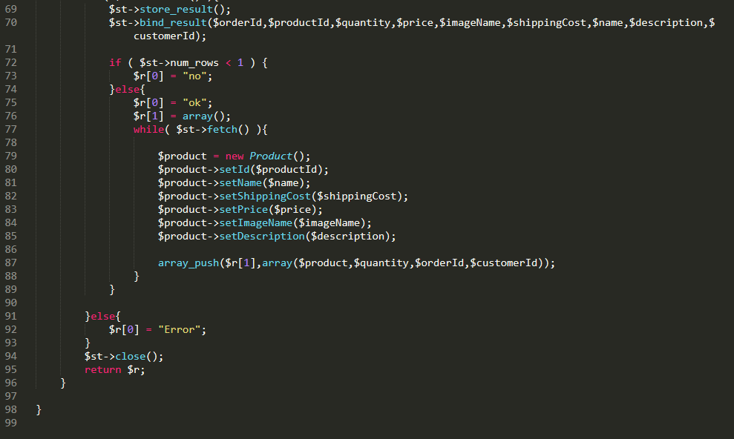

Fig: codes for order control

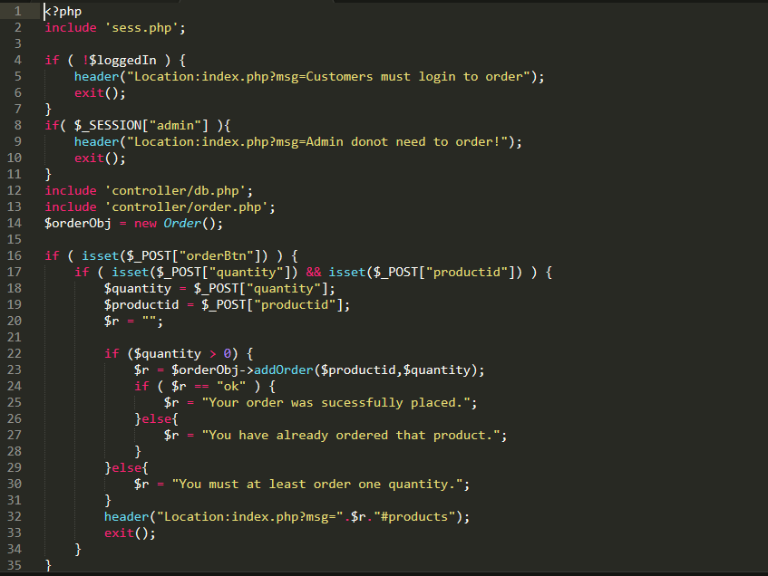

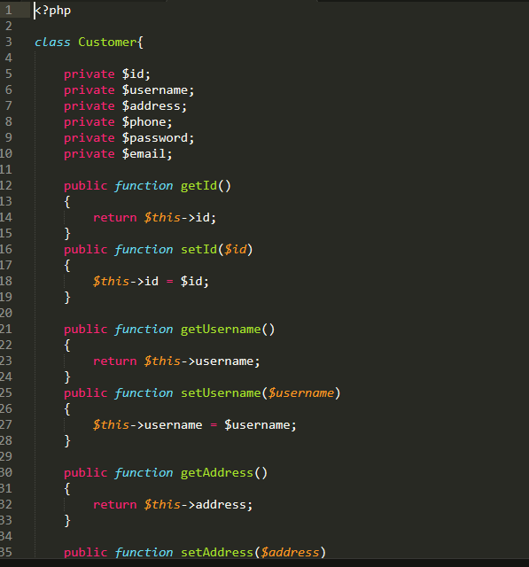

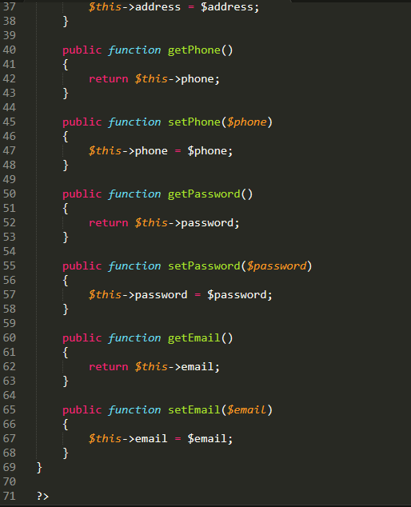

Fig: codes of user control

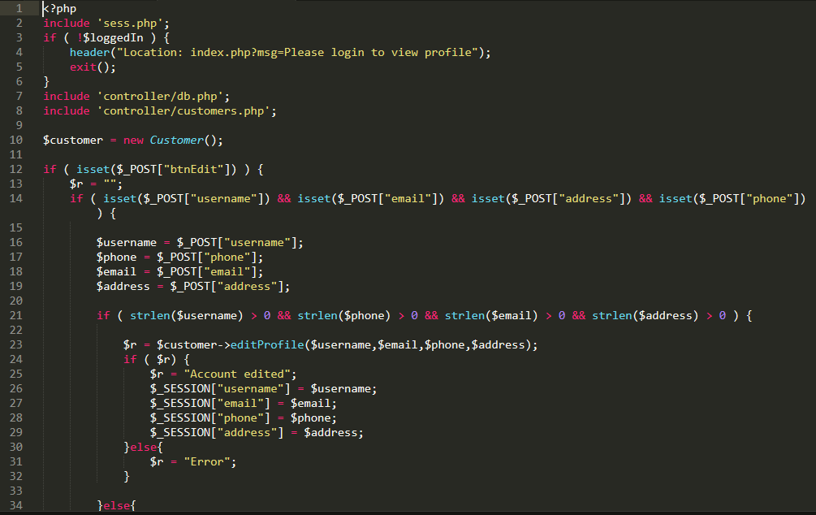

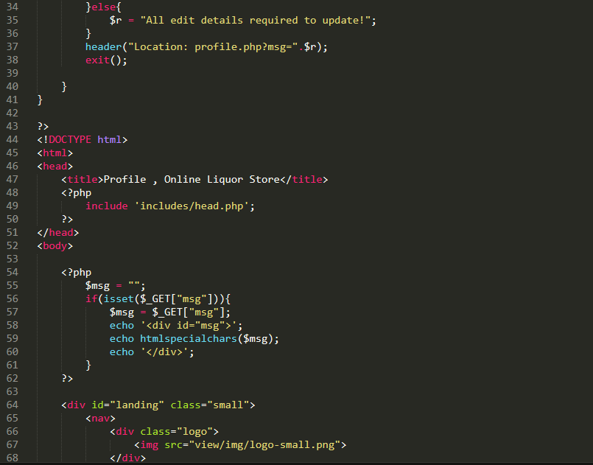

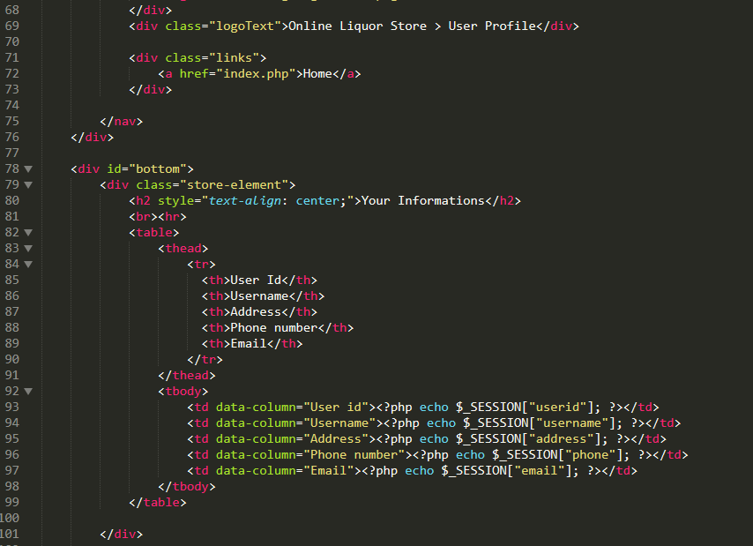

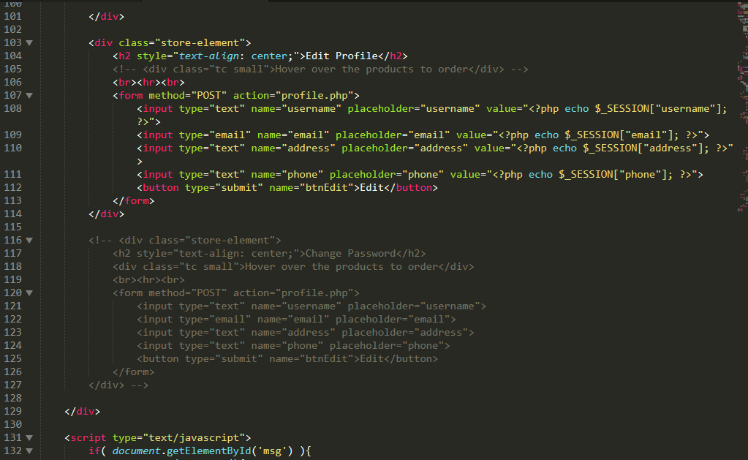

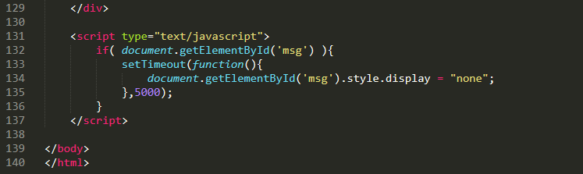

Fig: all the codes after the logged in into the system.

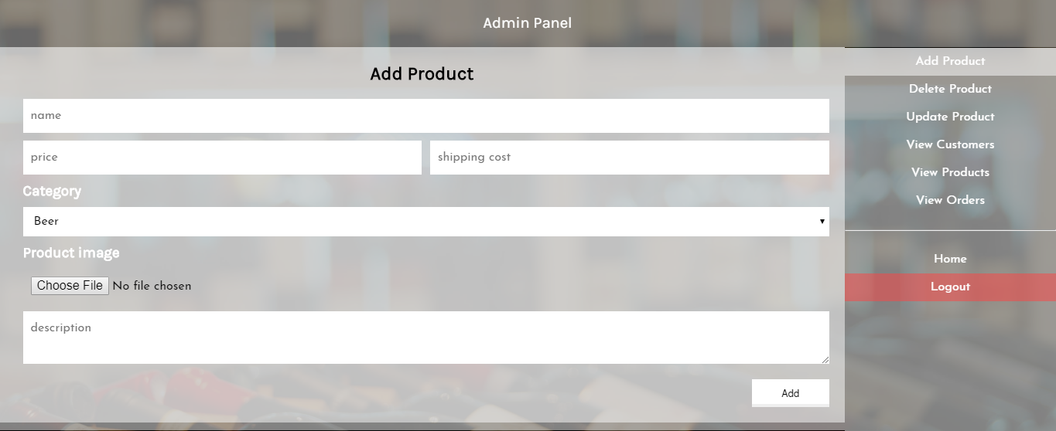

Fig: admin panel

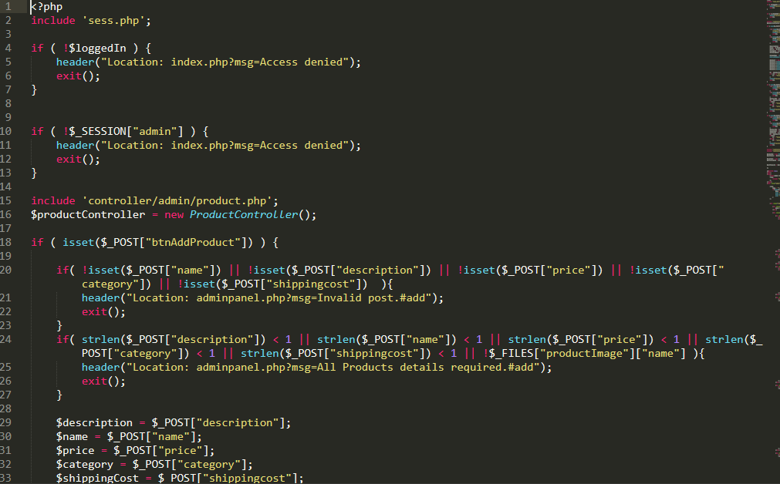

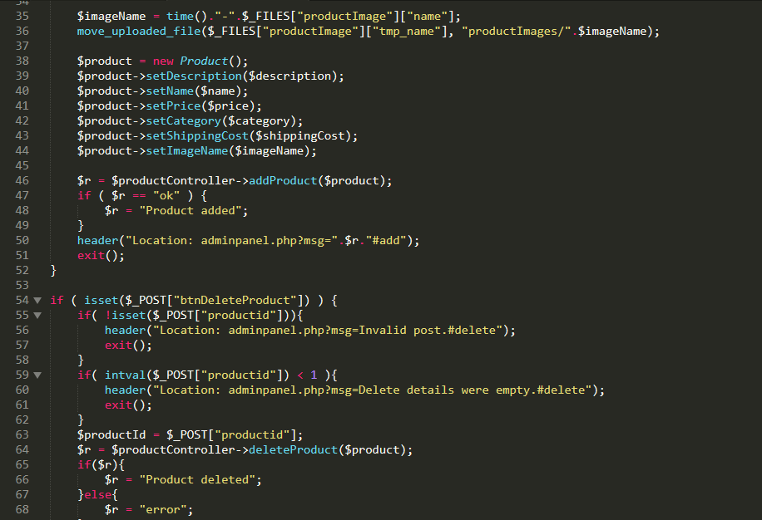

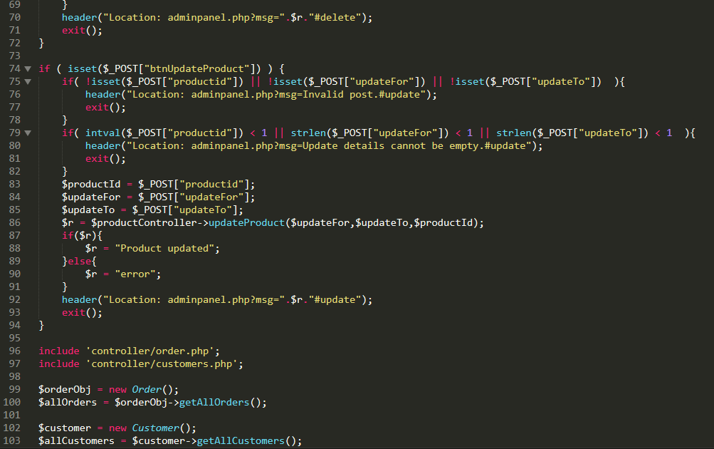

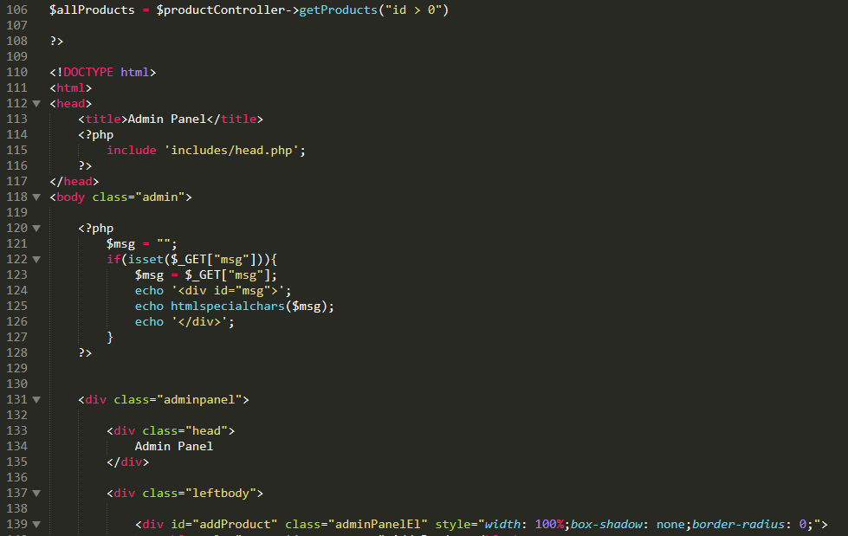

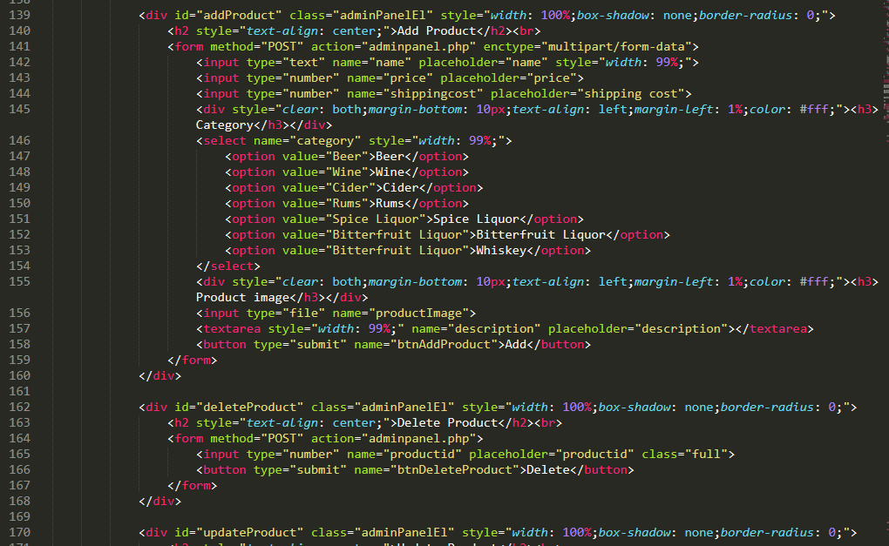

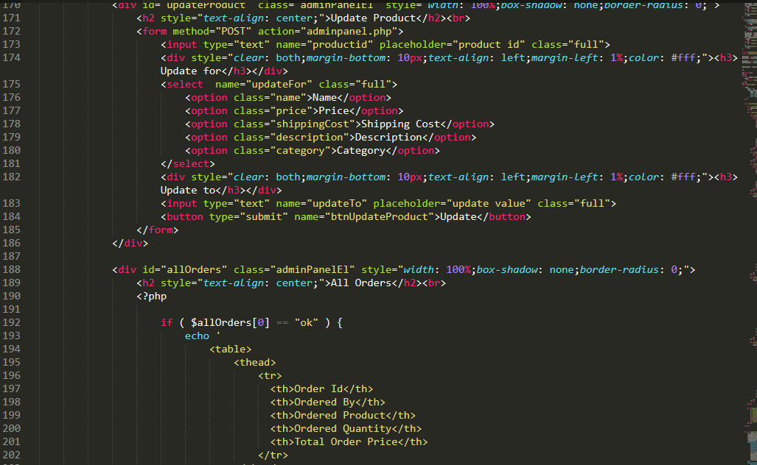

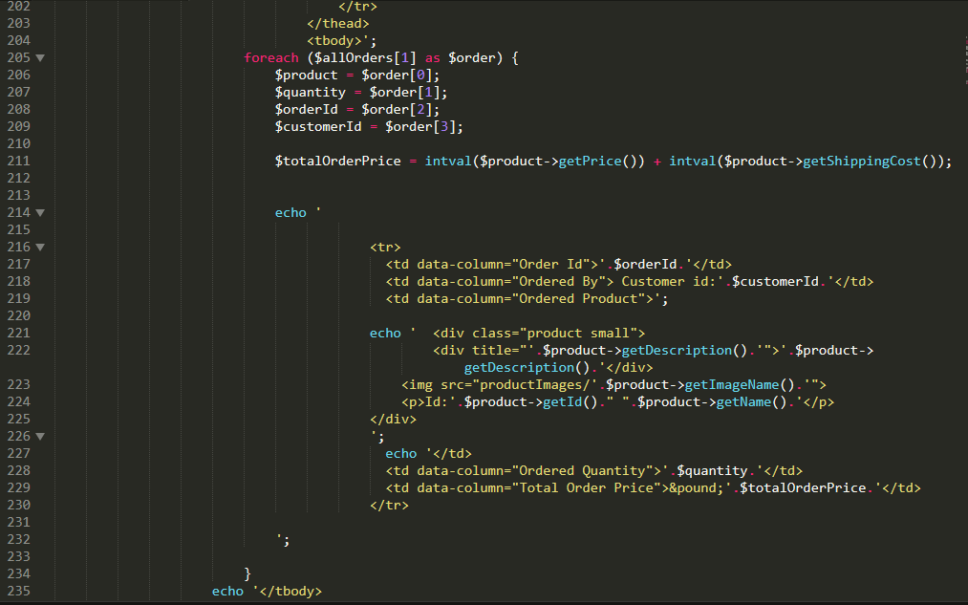

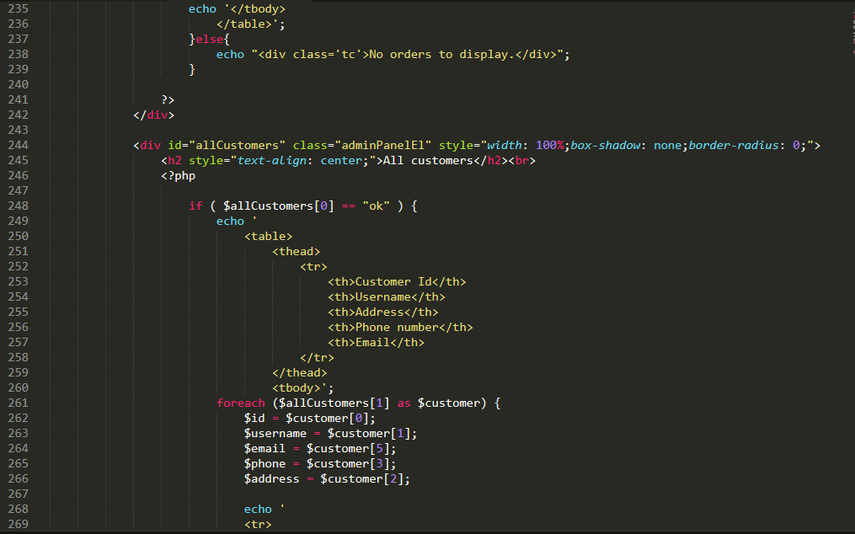

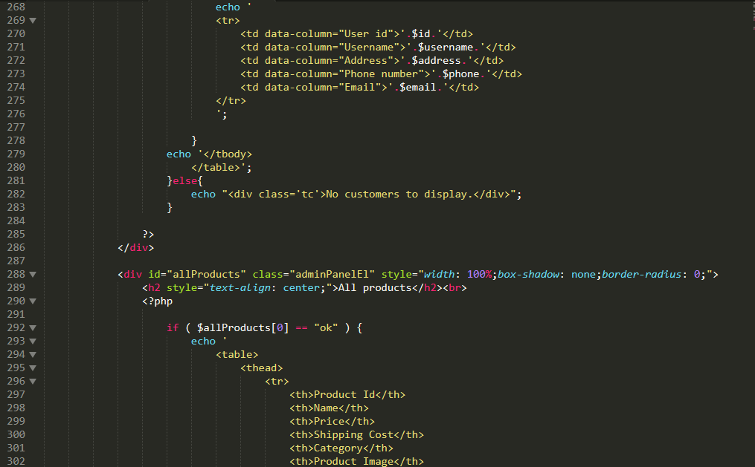

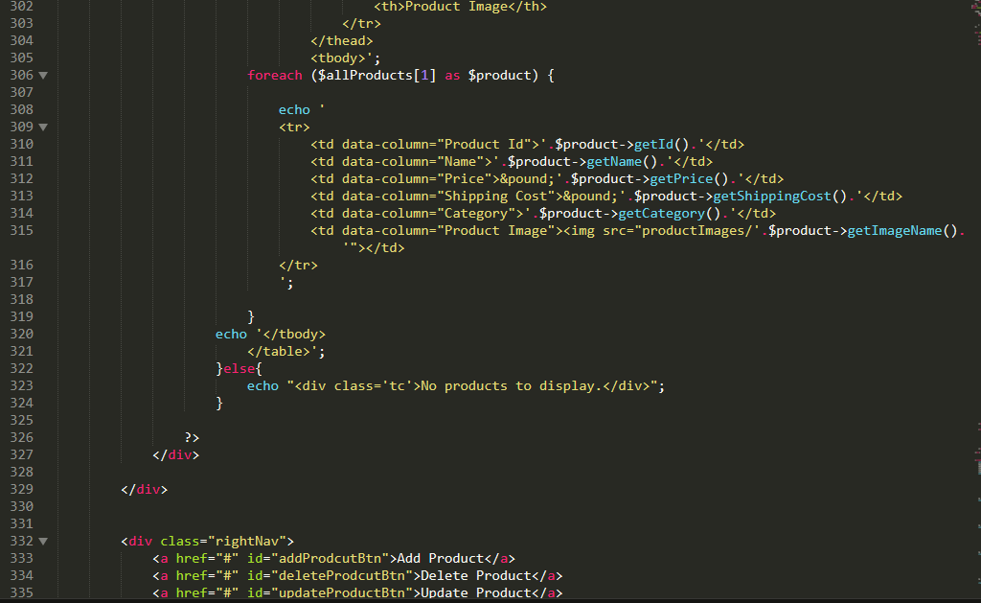

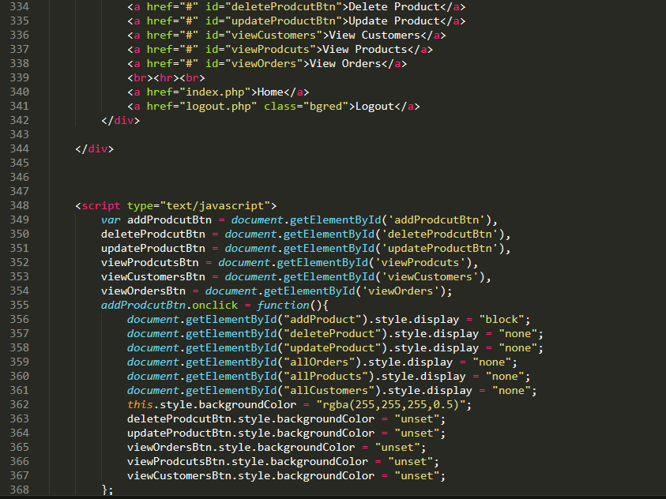

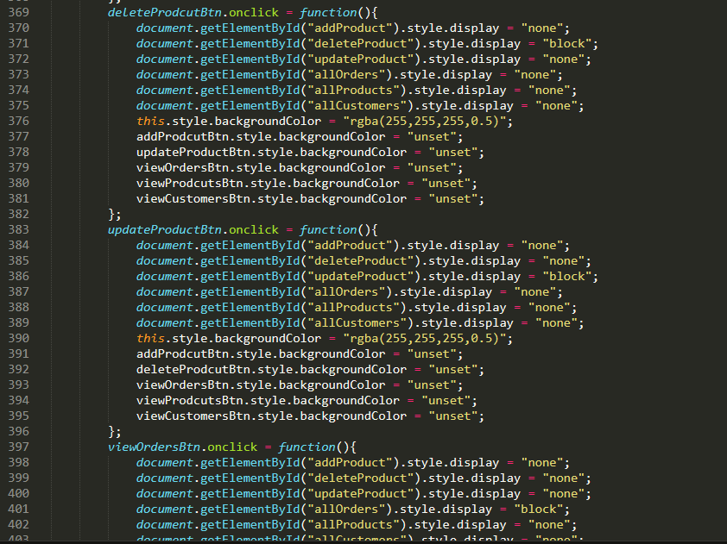

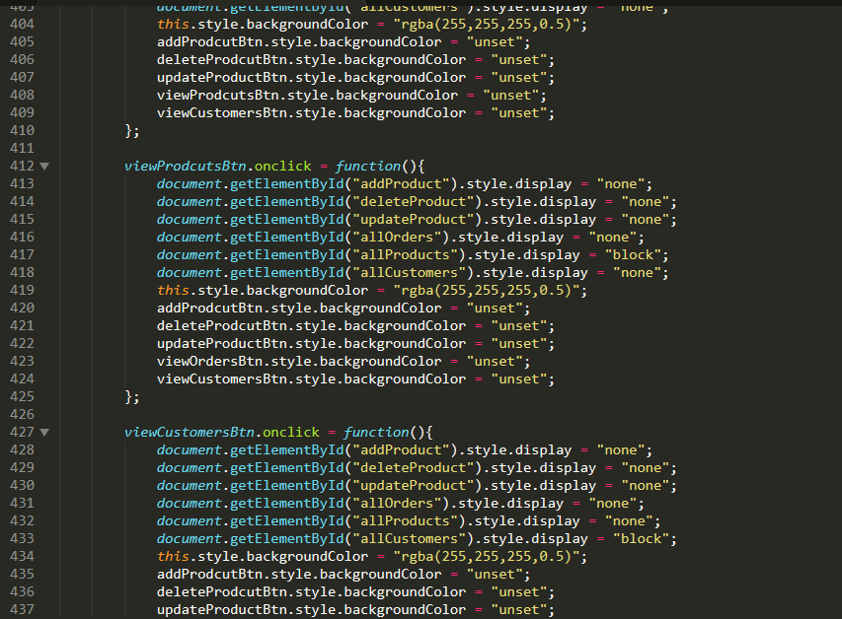

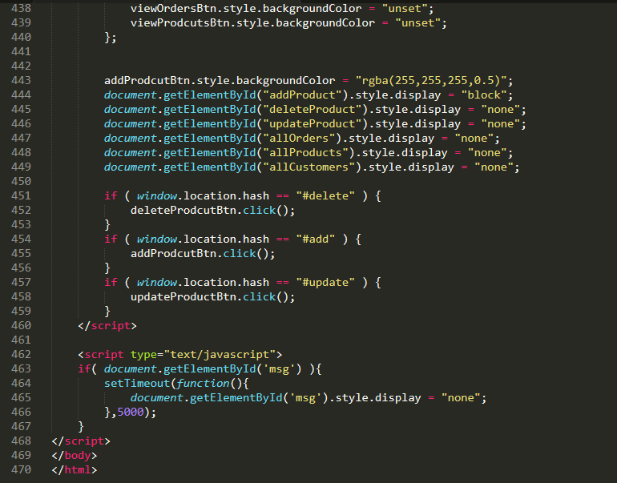

Fig: codes of the admin panel.

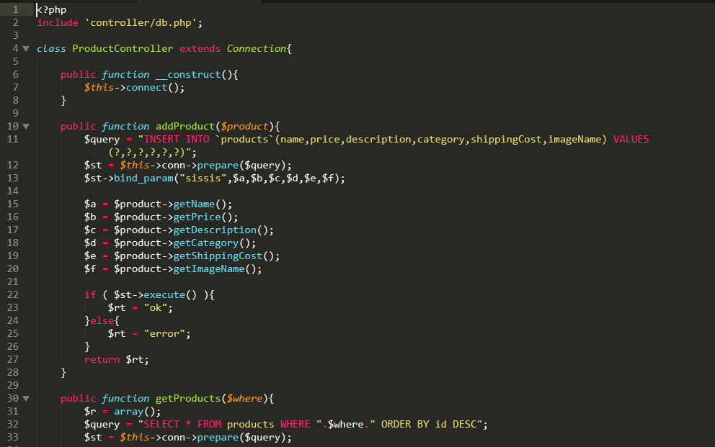

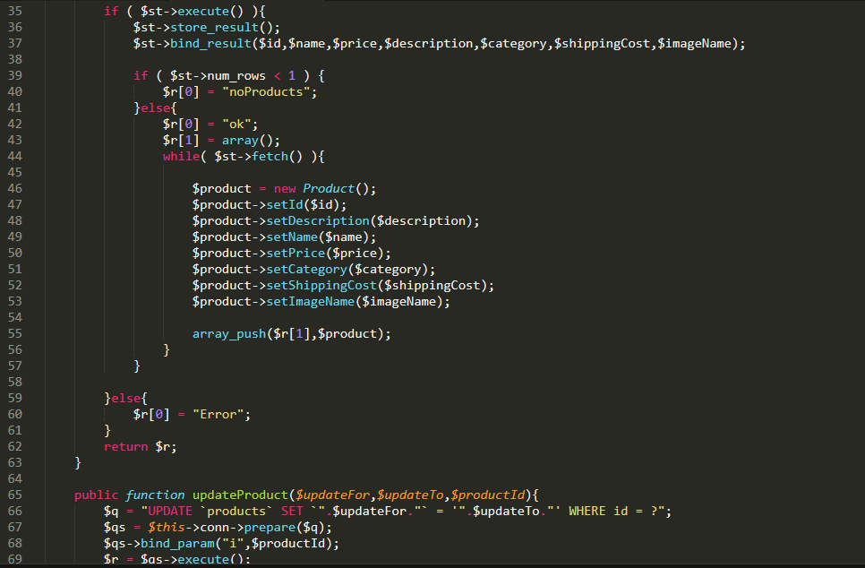

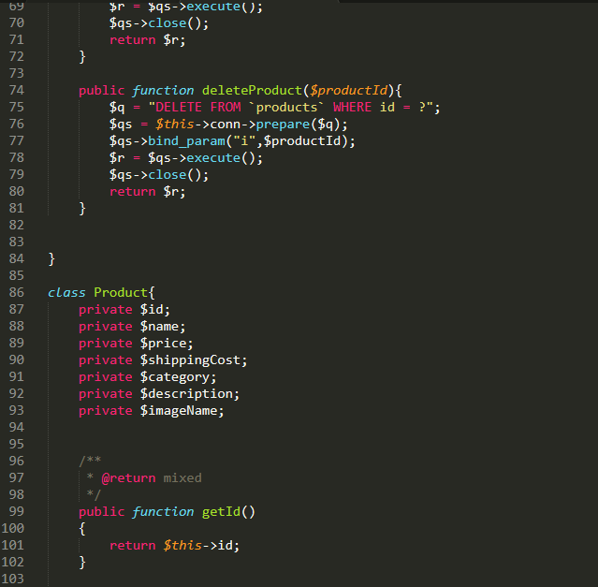

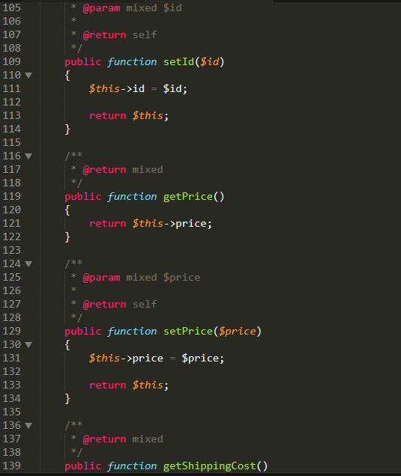

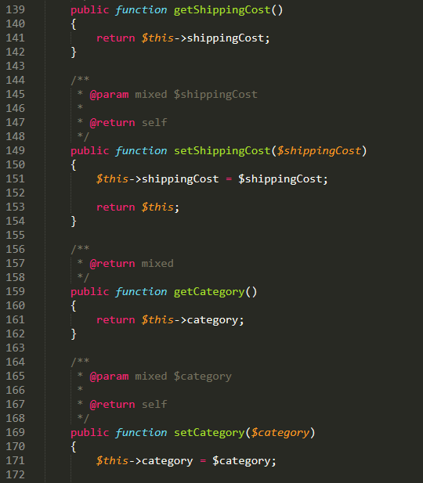

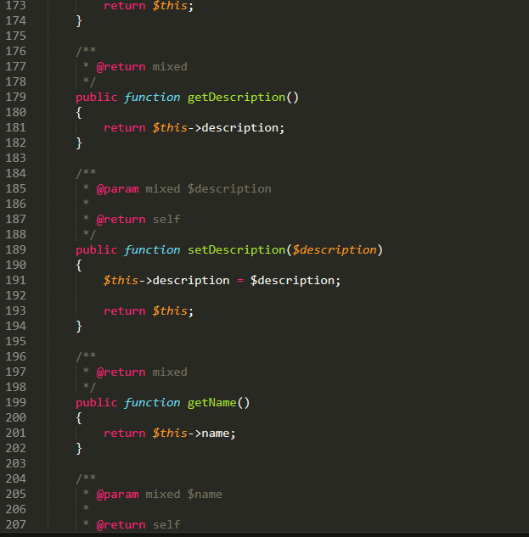

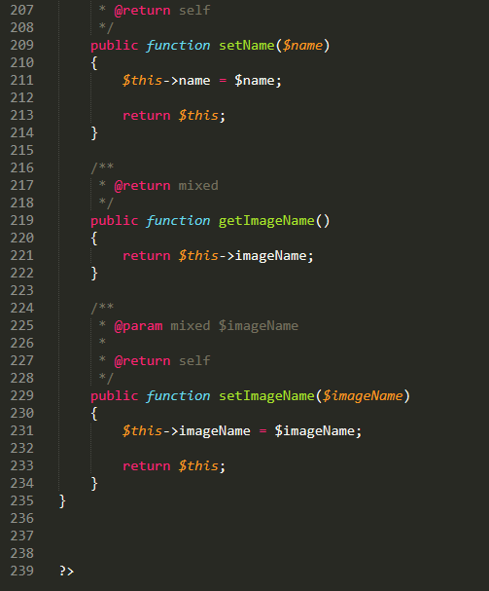

Fig: product control codes

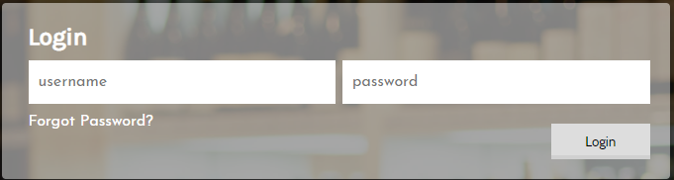

Fig: forget password

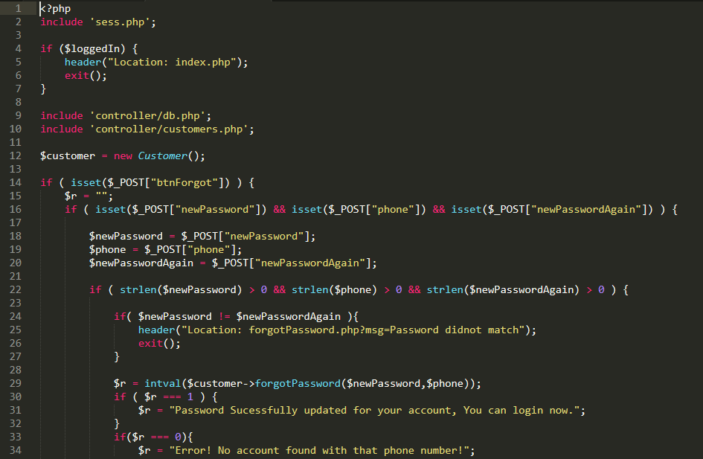

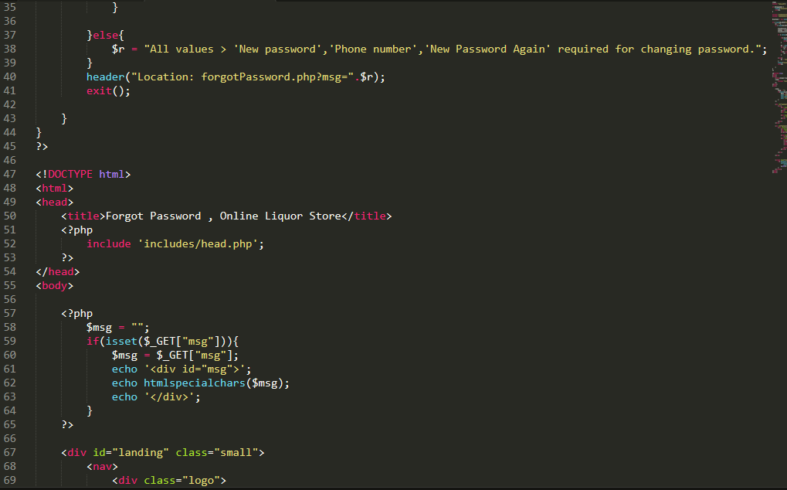

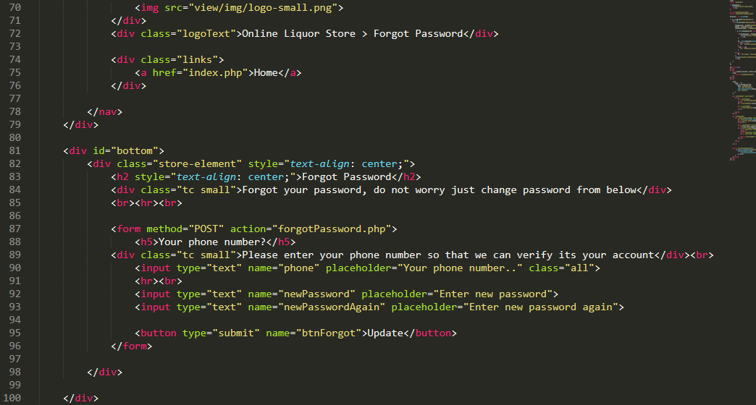

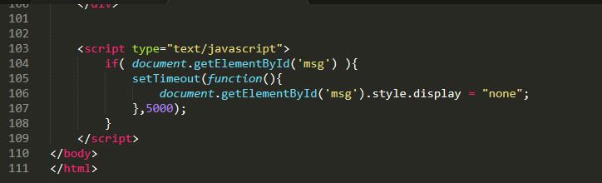

Fig: codes for forget password.

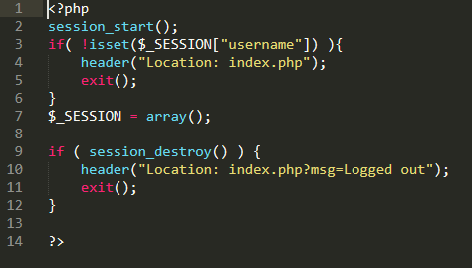

Fig: codes for logout

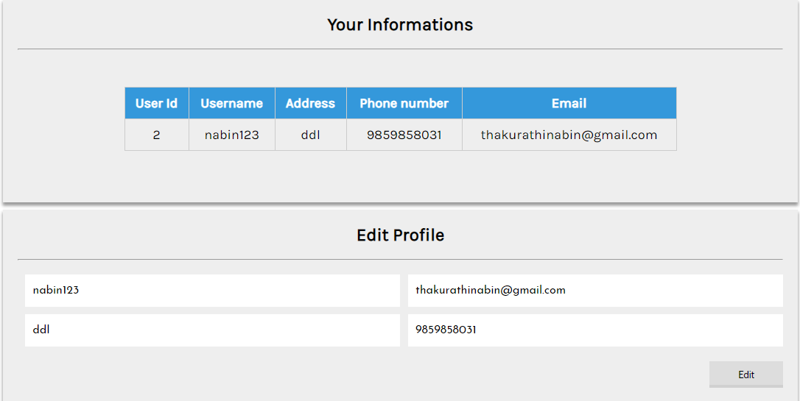

Fig: edit profile form

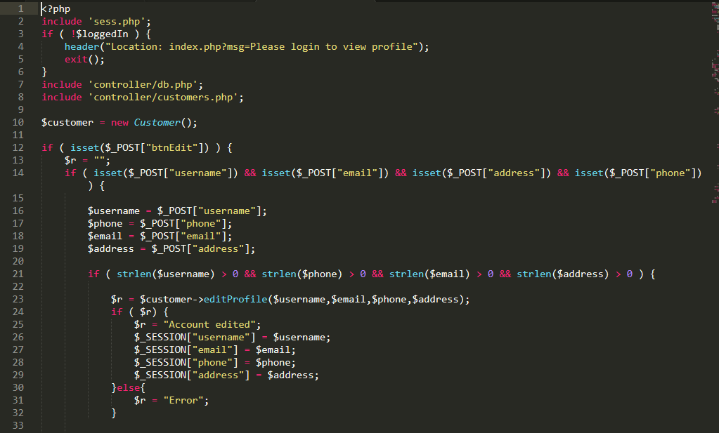

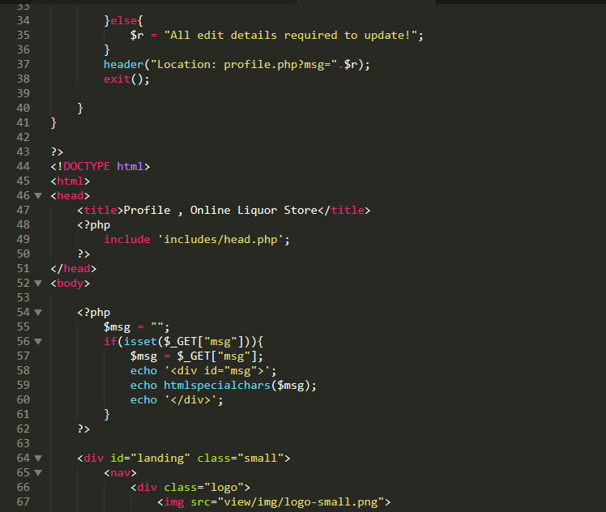

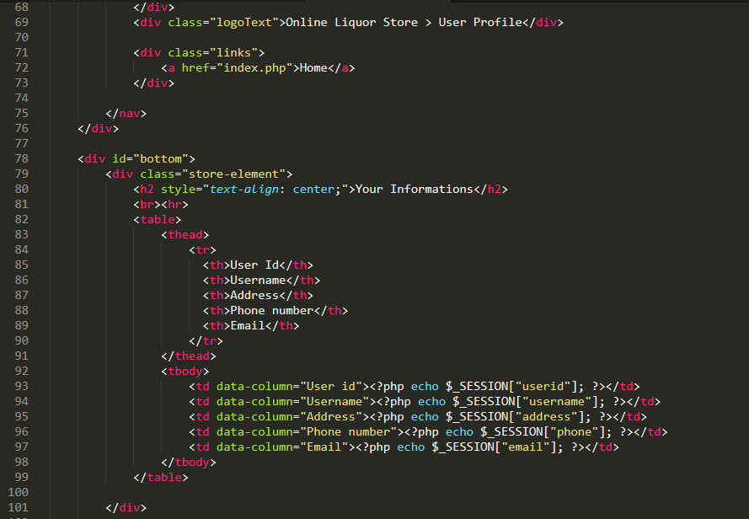

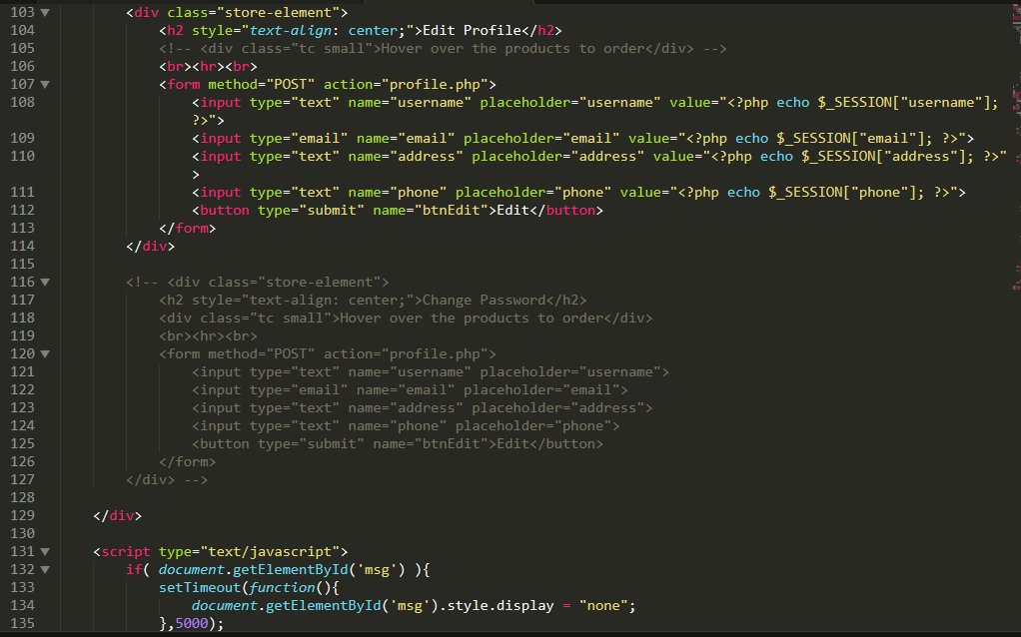

Fig: codes for editing profile

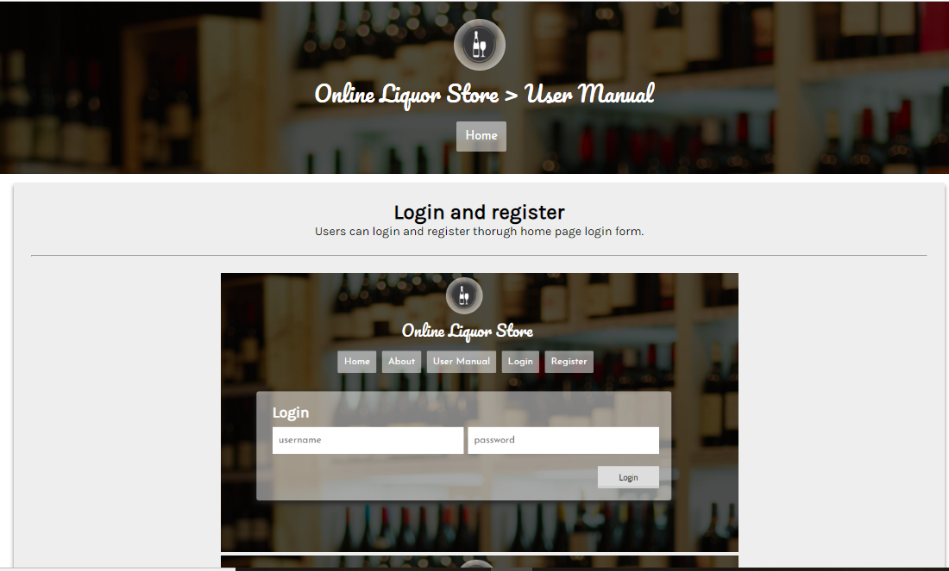

Fig: user manual page.

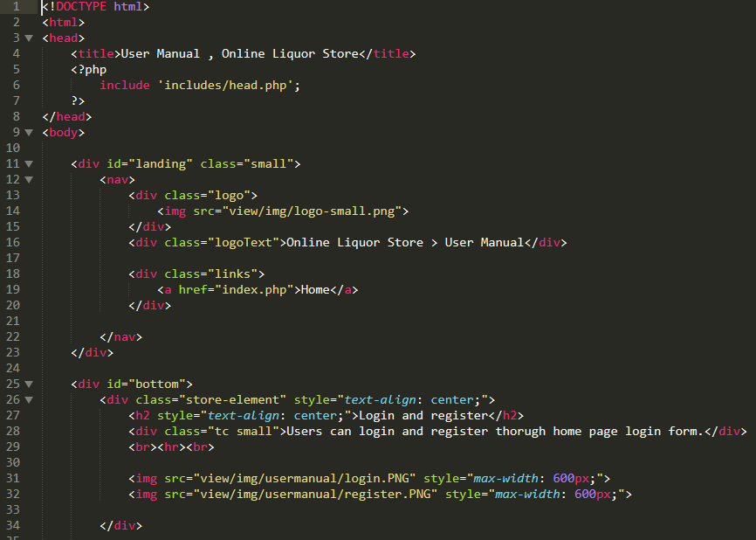

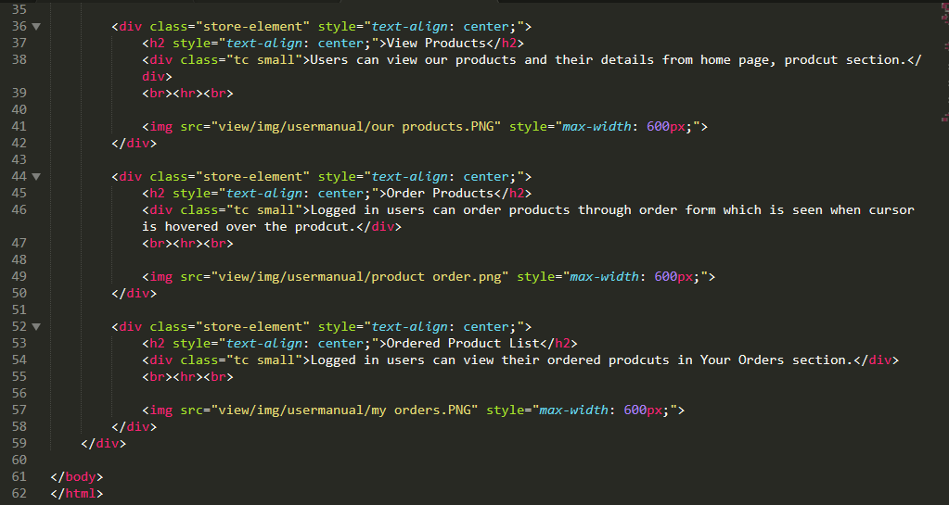

Fig: codes for user manual.